Front End Engineering-II

Project Report Semester-IV (Batch-2022)

**DREAM** **TRAVELS**



**Supervised By: Submitted By:**

Dr. Raveesh Samkaria Rudrakshi 2210990747(G12)

Department of Computer Science and Engineering Chitkara University Institute of Engineering &Technology,

Chitkara University , Punjab

ABSTRACT

Dream Travels is a unique and innovative travel agency that promises to fulfill people's dreams of traveling anywhere in the world at affordable prices. Utilizing only HTML and CSS, we have developed a user-friendly and visually appealing platform that provides a seamless booking experience for our customers.

Our project seeks to transform the travel industry by providing customized and stress-free travel solutions for both individuals and groups. Using HTML and CSS, we've built a dynamic website showcasing a diverse array of destinations, packages, and services. With Dream Travels, customers can explore different travel options like flights, accommodations, tours, and activities, all personalized to fit their preferences and budget. Our user-friendly interface makes it easy for users to search, compare, and book their dream vacation with just a few clicks .One of the key features of our project is its affordability. We understand that traveling can be expensive, which is why we strive to offer competitive prices without compromising on quality. By leveraging HTML and CSS, we have optimized our website's performance and functionality, ensuring a smooth and efficient booking process for our customers.

Furthermore, Dream Travels prioritizes customer satisfaction and convenience. Our website is designed to be responsive and allowing users to access it anytime, anywhere. Whether planning a last-minute getaway or a long-awaited vacation, our platform makes it easy for customers to find the perfect travel solution .Dream Travels offers helpful resources and information to assist customers in planning their trips, including destination guides, travel tips, packing lists, and itinerary suggestions.

Overall, our project showcases the power and versatility of HTML and CSS in creating functional and aesthetically pleasing websites. Dream Travels offers a seamless and enjoyable booking experience, making it easier than ever for people to turn their travel dreams into reality. With our commitment to affordability, convenience, and customer satisfaction, we are confident that Dream Travels will become the go-to destination for travelers worldwide.

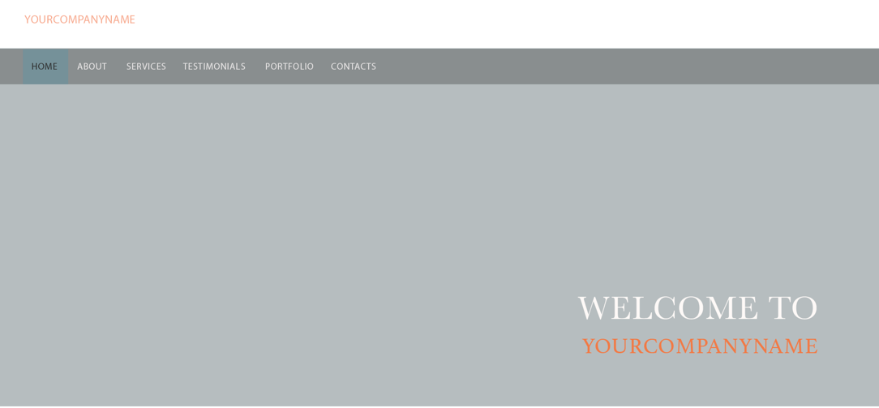

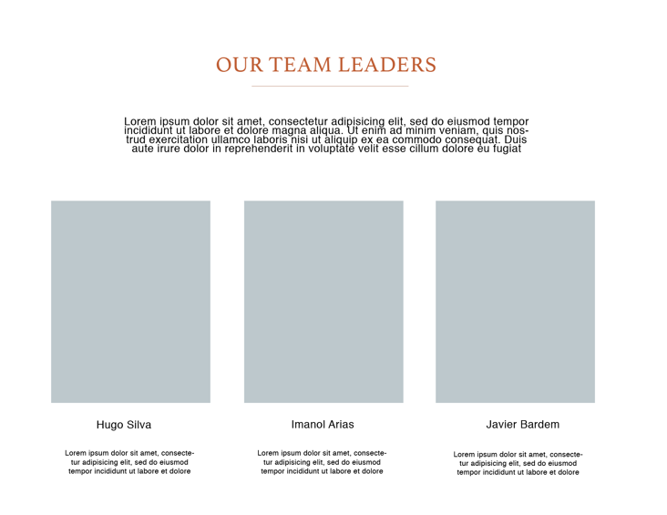

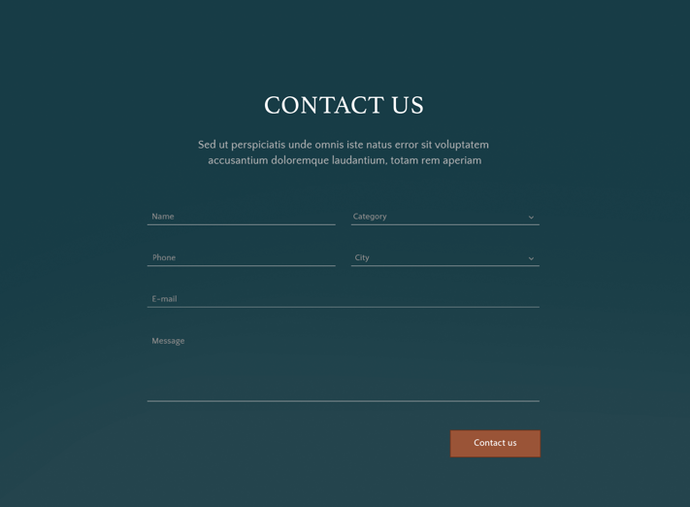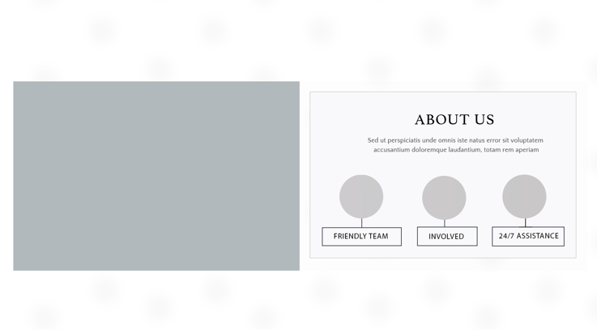

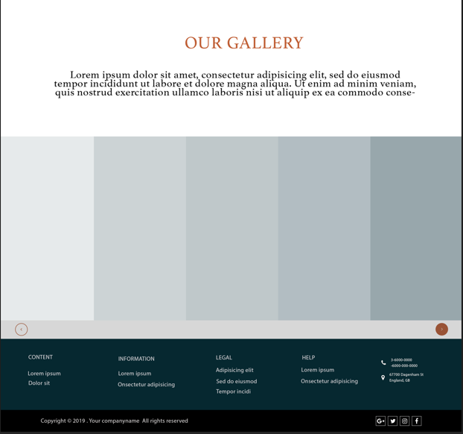

INDEX

|  |  |  |
| --- | --- | --- |
| S NO. | TITLE | PAGE NO. |
| 1. | INTRODUCTION | 7,8 |
| 2. | PROBLEM STATEMENT | 9 |
| 3. | SOFTWARE REQUIREMENTS | 9,10 |
| 4. | PROPOSED DESIGN | 11 - 39 |
| 5. | RESULTS | 40 - 82 |
| 6. | REFERENCES | 83 |
|  |  |  |

1. INTRODUCTION

In a world filled with endless possibilities and breathtaking destinations, the desire to explore and experience new cultures has become a fundamental aspect of modern life. However, the process of planning and booking a vacation can often be overwhelming and time-consuming, leaving travelers feeling stressed and frustrated. Recognizing this challenge, we embarked on a journey to create a solution that would revolutionize the way people plan and book their travel adventures. The result of our endeavor is Dream Travels, a dynamic and user-friendly travel platform designed to make travel dreams a reality.

1.1 Background

The idea for Dream Travels was born out of a deep passion for travel and a desire to simplify the often complex and daunting task of vacation planning. As avid travelers ourselves, we understand the excitement and anticipation that comes with exploring new destinations, but we also recognize the challenges and frustrations that can arise during the planning process. From searching for flights and accommodations to arranging transportation and activities, planning a vacation requires careful coordination and meticulous attention to detail. With Dream Travels, we sought to create a comprehensive solution that would streamline the entire travel experience, making it easier and more enjoyable for travelers around the world.

1.2 Objectives

The primary objective of Dream Travels is to provide travelers with a seamless and hassle-free booking experience that meets their needs and preferences. We aim to achieve this by offering a wide range of destinations, packages, and services, all tailored to the unique interests and budgets of our customers. Additionally, we strive to empower travelers with valuable resources and information to help them plan their trips effectively, from destination guides and travel tips to packing lists and itinerary suggestions. By combining cutting-edge technology with personalized service, our goal is to redefine the travel industry and inspire a new generation of adventurers to explore the world.

1.3 Significance

The significance of Dream Travels lies in its ability to democratize travel and make it accessible to people from all walks of life. By offering competitive prices and a user-friendly booking platform, we aim to break down barriers and make travel dreams a reality for individuals and families alike. Whether it's a budget-friendly getaway or a luxury vacation, Dream Travels provides options for every type of traveler, ensuring that no dream is too big or too small. Furthermore, by leveraging the power of technology, we are able to reach a global audience and connect travelers with unique and exciting experiences around the world. In doing so, we hope to foster a sense of curiosity, adventure, and cultural appreciation that transcends borders and unites people from diverse backgrounds.

1.4 Conclusion

In conclusion, Dream Travels represents a new era of travel planning, where innovation meets convenience and affordability. With a dedication to customer satisfaction, a commitment to excellence, and a passion for exploration, we are proud to introduce a platform that empowers travelers to dream big and explore the world with confidence. Whether you're embarking on a solo adventure, planning a romantic getaway, or organizing a family vacation, Dream Travels is here to turn your travel dreams into reality. Join us on this journey and let the adventure begin!

2. Problem Statement

The travel industry is vast and ever-evolving, with millions of people around the world seeking to explore new destinations and experiences. However, planning a vacation can often be a complex and time-consuming task, with travelers faced with the challenge of navigating through numerous options and making decisions that align with their preferences and requirements. Traditional travel agencies may offer assistance, but they often lack personalized solutions and fail to cater to the unique needs of individual travelers. Additionally, the COVID-19 pandemic has brought about unprecedented disruptions and uncertainties, further complicating the travel planning process. In light of these challenges, there is a growing demand for a user-friendly and comprehensive travel platform that provides tailored solutions and valuable resources to help travelers plan their trips effectively.

3. Software Requirements

To address the problem statement outlined above, the Dream Travels project requires the following software components:

* HTML: HTML (Hypertext Markup Language) serves as the backbone of the Dream Travels website, providing the structure and content for each page. Through HTML, we define headings, paragraphs, lists, links, and images, ensuring a well-organized and accessible user interface.
* CSS: CSS (Cascading Style Sheets) plays a crucial role in enhancing the visual appeal and user experience of the Dream Travels website. By controlling the presentation and styling of HTML documents, CSS allows us to customize colors, fonts, margins, borders, and layout, creating a cohesive and professional design across all pages.
* Responsive Design: With the prevalence of mobile devices and varying screen sizes, responsive design is essential for ensuring that the Dream Travels website is accessible and functional on all devices. Leveraging responsive design techniques such as fluid grids, flexible images, and media queries, we ensure that the website adapts seamlessly to different screen sizes and resolutions, providing a consistent user experience.
* JavaScript: JavaScript adds interactivity and dynamic functionality to the Dream Travels website, enhancing user engagement and usability. Through JavaScript, we can implement features such as interactive forms, dynamic content updates, and smooth page transitions, making the website more intuitive and user-friendly. Additionally, JavaScript allows us to integrate third-party APIs for features like maps, weather forecasts, and real-time booking updates, further enhancing the functionality of the platform.

By incorporating these software components into the Dream Travels project, we can create a robust, user-friendly, and responsive travel platform that meets the needs of modern travelers. With HTML, CSS, and JavaScript working together seamlessly, we can provide an intuitive and enjoyable booking experience for customers, helping them plan their dream vacations with ease and confidence.

4. Proposed Design

The provided HTML code forms the foundation of the Dream Travels website, which aims to offer personalized and hassle-free travel solutions to individuals and groups. To achieve this goal, the following proposed design and methodology outline the steps to enhance the functionality, usability, and aesthetics of the website:

* Responsive Design: The first step in the proposed design is to ensure that the website is responsive and accessible across all devices, including desktops, laptops, tablets, and smartphones. This involves optimizing the layout and content of the website to adapt seamlessly to different screen sizes and resolutions. By incorporating responsive design techniques such as fluid grids, flexible images, and media queries, we can provide a consistent and user-friendly experience for travelers on the go.
* Visual Design Enhancements: Building upon the existing design elements, the next step is to enhance the visual appeal of the website through CSS styling and layout adjustments. This includes refining the typography, color scheme, and imagery to create a cohesive and professional look. Additionally, we will optimize the placement and sizing of elements to improve readability and navigation, ensuring that users can easily find the information they need and take action.
* Navigation and User Experience: A key aspect of the proposed design is to improve the navigation and user experience of the website. This involves restructuring the header and footer sections to provide clear and intuitive navigation links, making it easier for users to explore different sections of the website. Additionally, we will implement smooth scrolling and anchor links to enable seamless navigation between sections, enhancing the overall user experience.
* Content Optimization: To enhance the effectiveness of the website in communicating its value proposition and services, we will optimize the content throughout the website. This includes refining the messaging, calls-to-action, and imagery to effectively convey the benefits of using Dream Travels for travel planning. Additionally, we will integrate dynamic content elements, such as testimonials and client reviews, to build credibility and trust with potential customers.
* Interactive Features: To further engage users and encourage interaction with the website, we will implement interactive features and functionalities using JavaScript. This includes adding interactive sliders and carousels to showcase travel destinations and packages, as well as integrating form validation and submission functionality for the contact form. By enhancing the interactivity of the website, we can create a more immersive and engaging experience for users, ultimately driving conversions and bookings.
* Performance Optimization: Finally, we will optimize the performance of the website to ensure fast loading times and smooth performance across all devices and platforms. This involves optimizing images, minifying CSS and JavaScript files, and leveraging caching techniques to reduce server response times. By prioritizing performance optimization, we can provide users with a seamless and efficient browsing experience, increasing satisfaction and retention.

4.1 File structure

Here is a screenshot of our project folder, where we've created all the files and resources for our Dream Travels website. You can see the HTML, CSS, and image files, along with the FontAwesome library we've linked to for icons. This folder contains everything we need to build and customize our website, from the layout and styling to the images and navigation elements. It's the heart of our project, where all the magic happens!

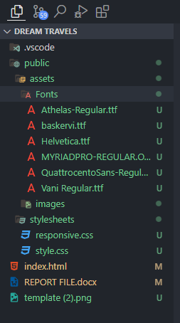

These are the screenshots showcasing the HTML code for our Dream Travels website project. It displays the structure and content of our web pages in code format.

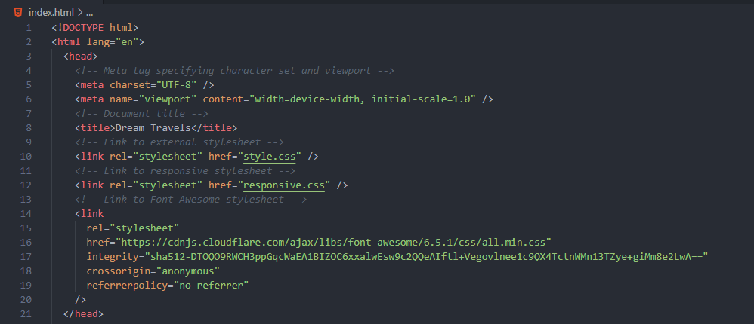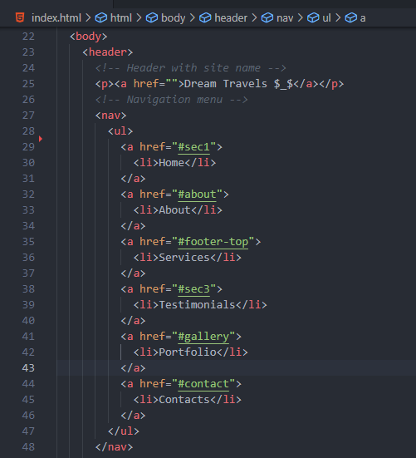

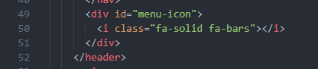

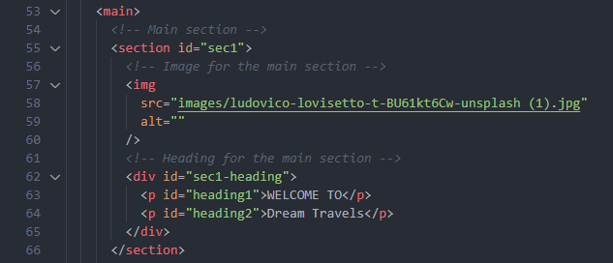

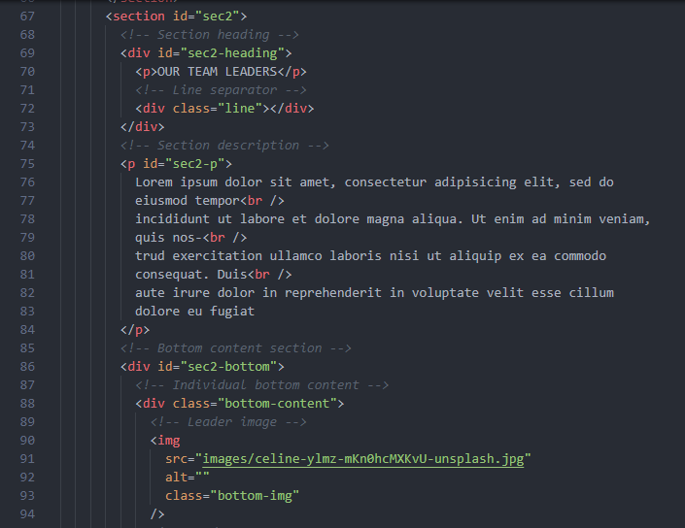

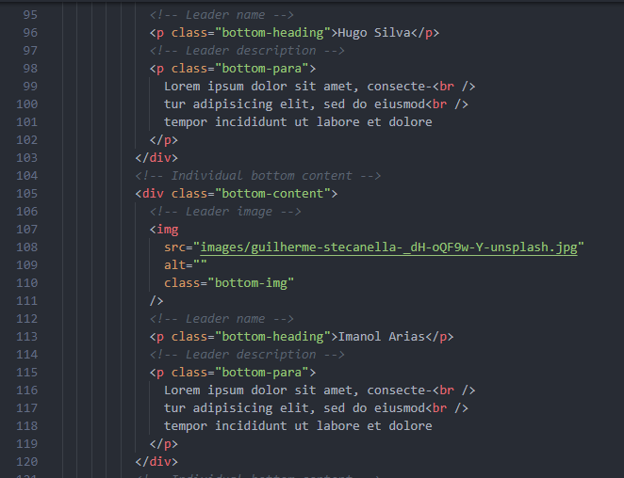

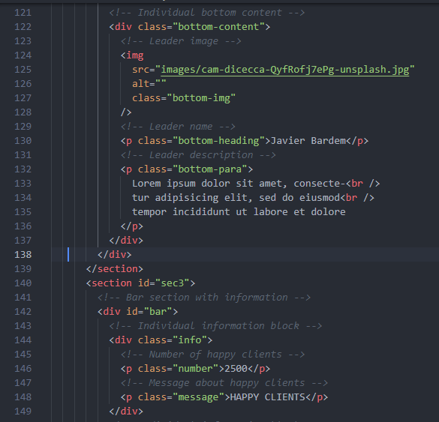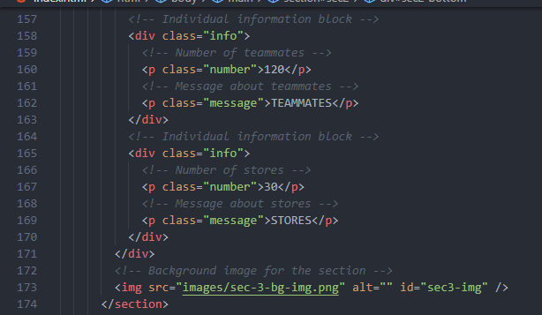

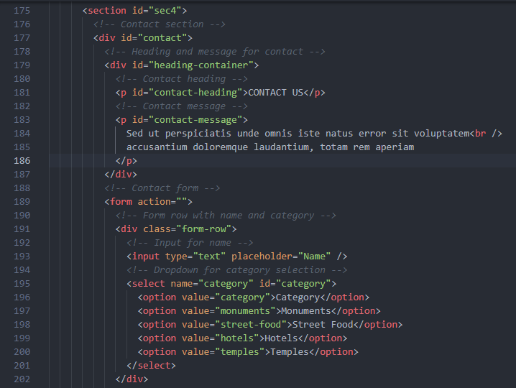

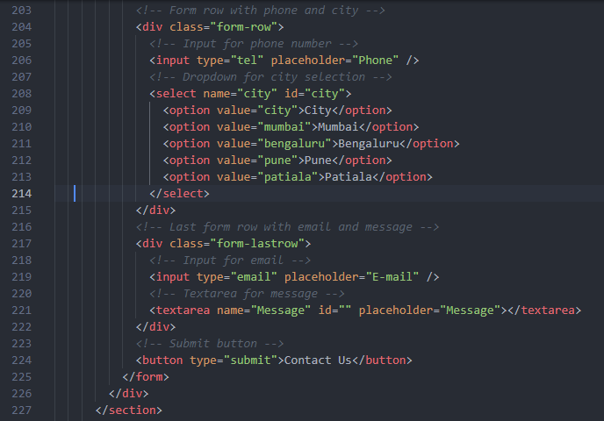

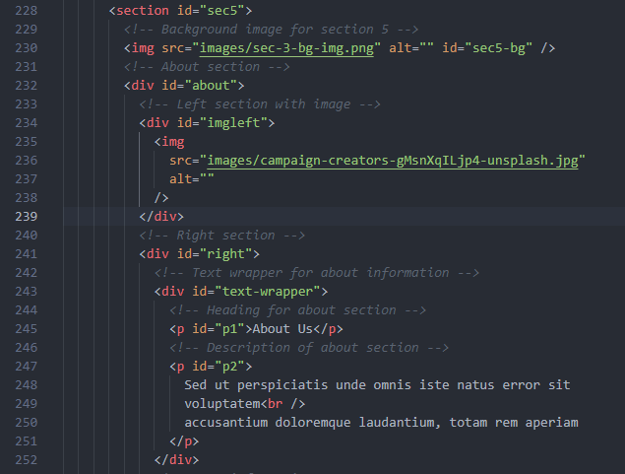

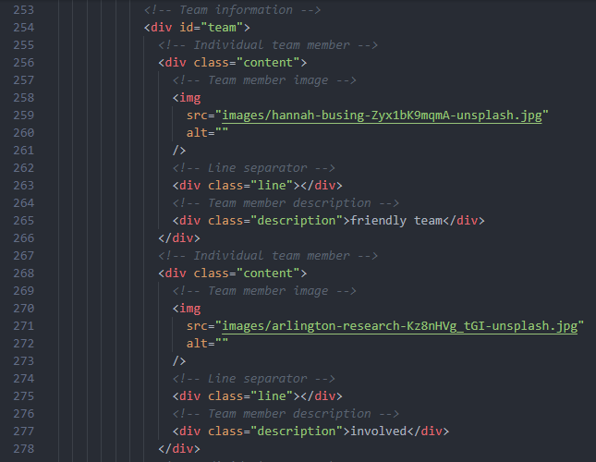

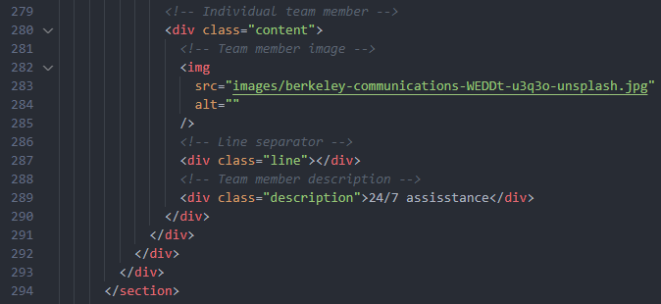

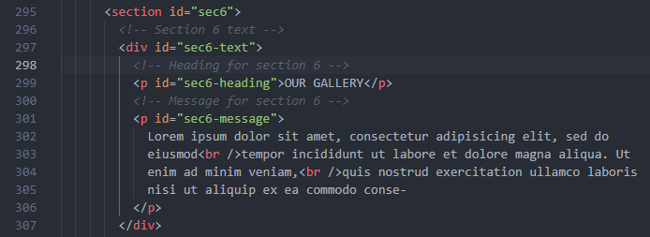

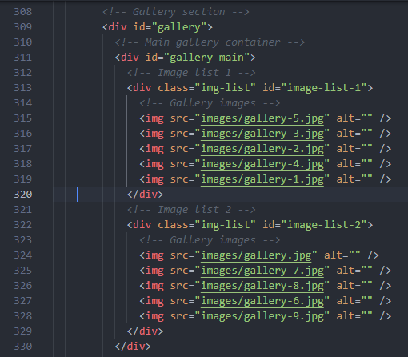

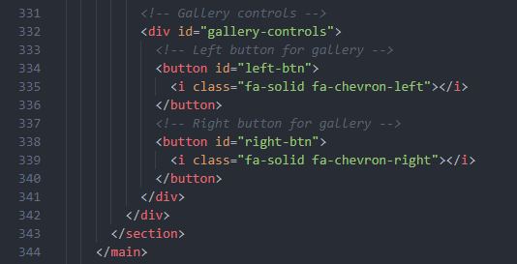

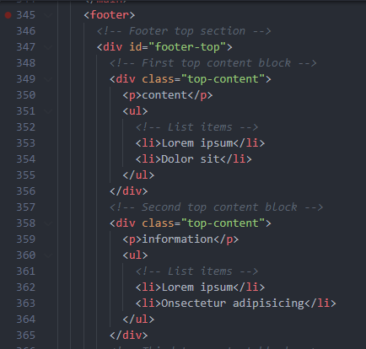

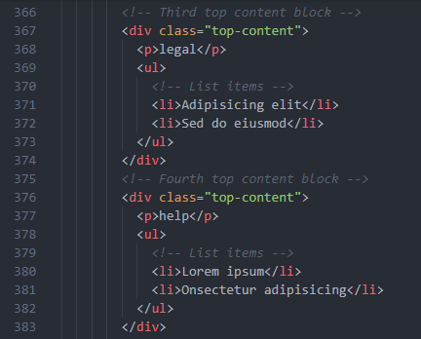

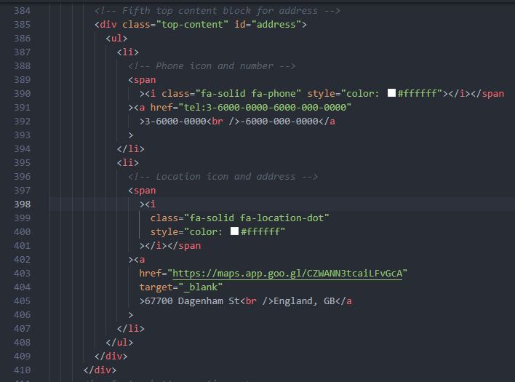

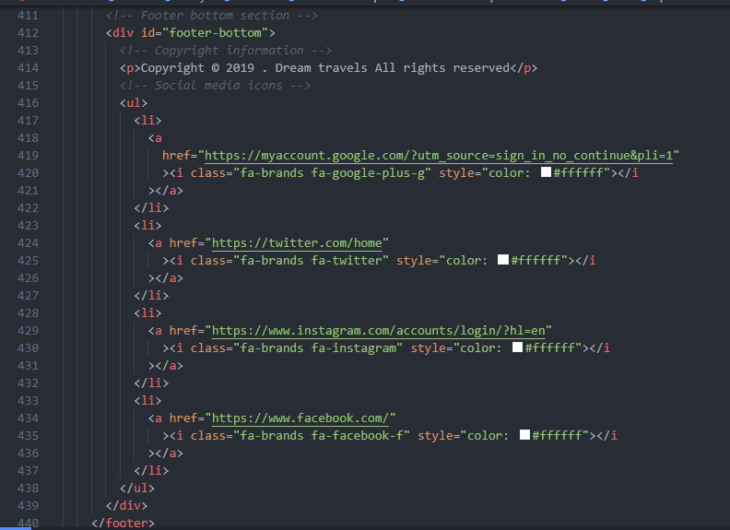

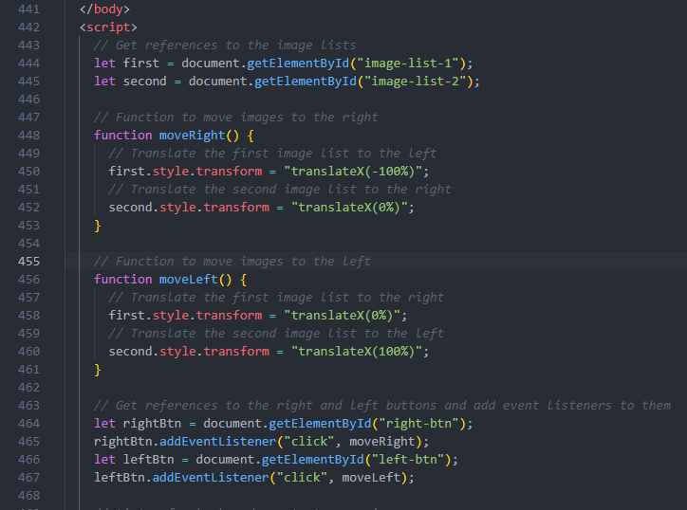

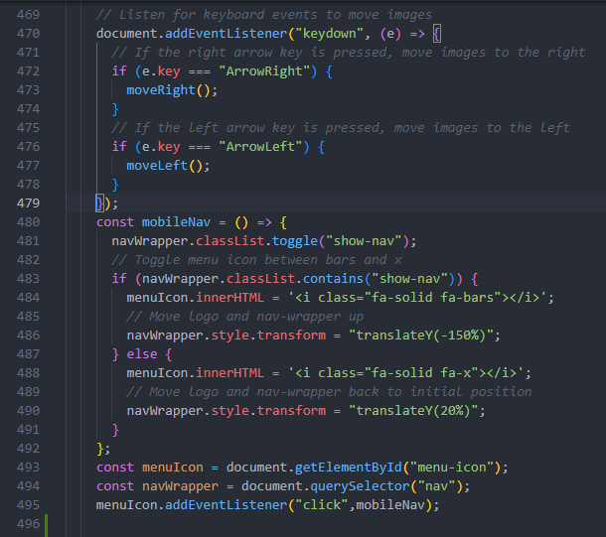

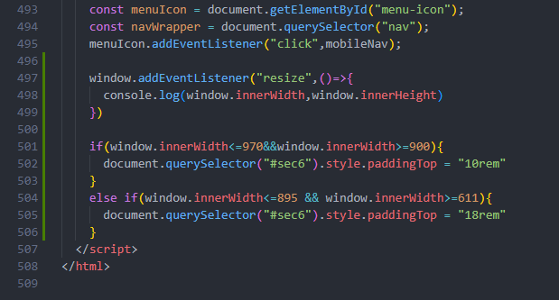

This is a screenshot displaying the CSS code for our Dream Travels website project. It shows the styling and design elements applied to our web pages.

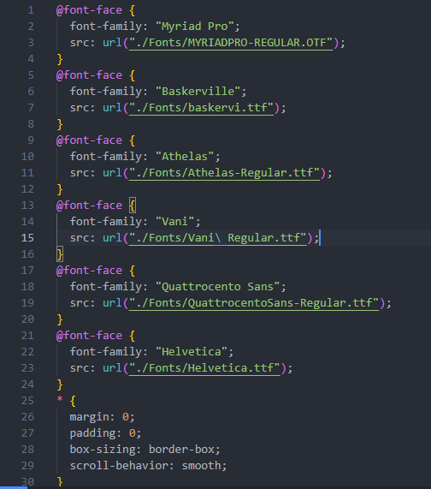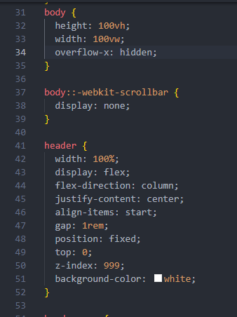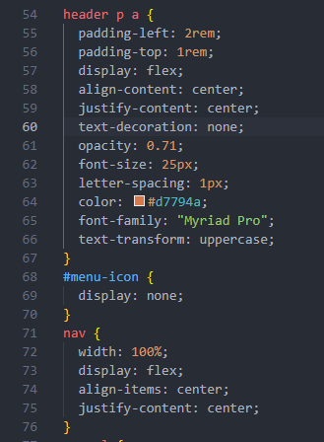

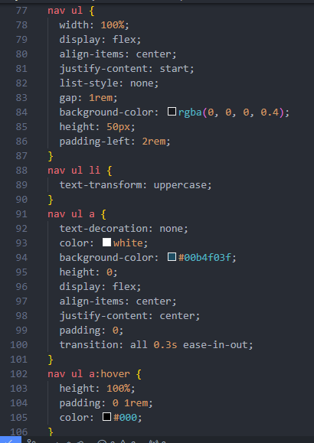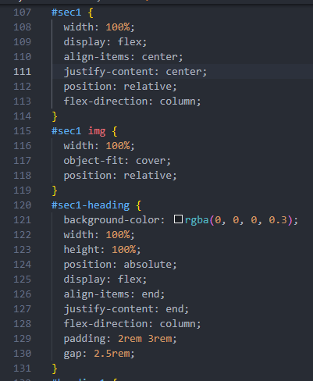

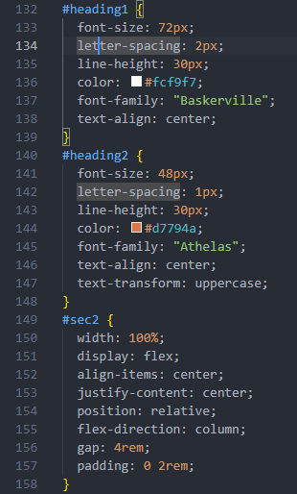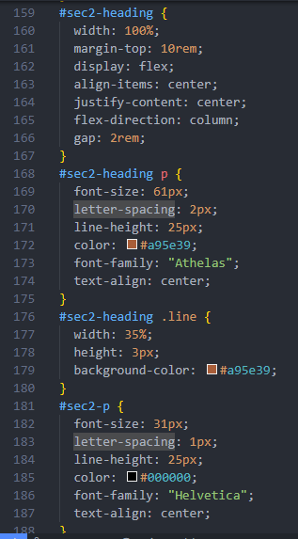

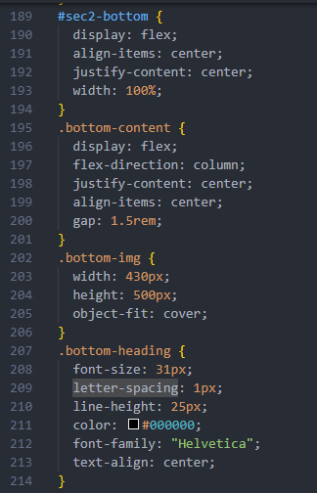 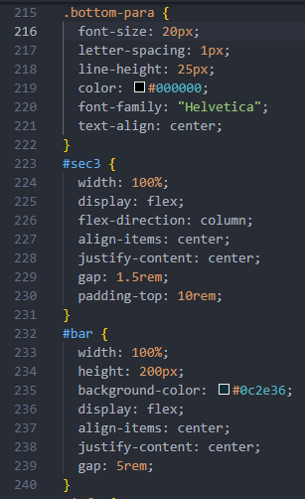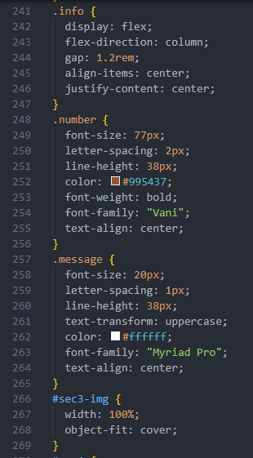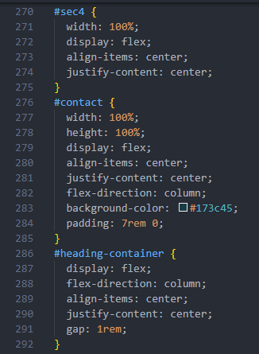

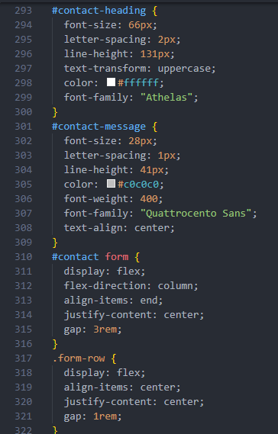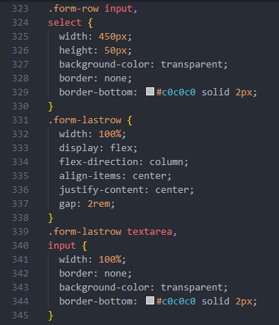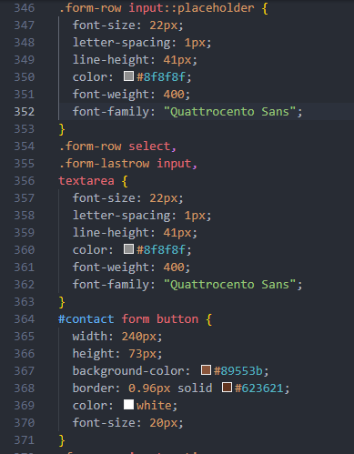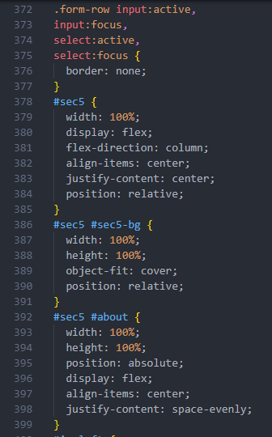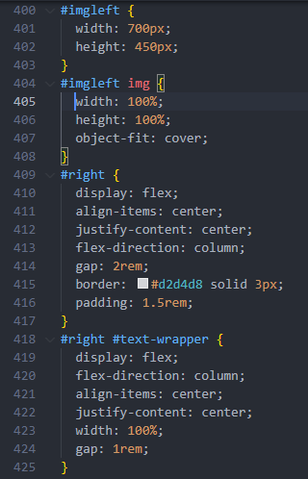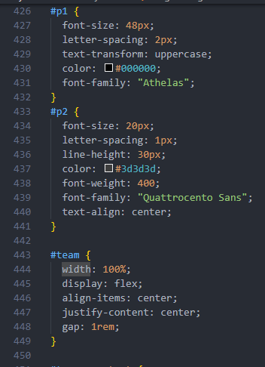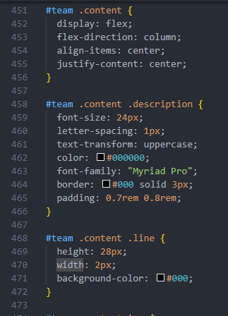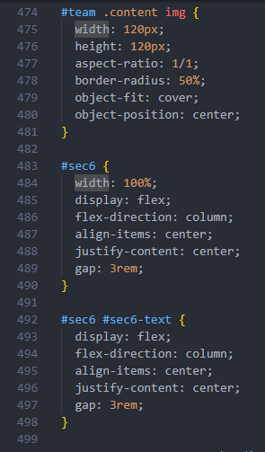

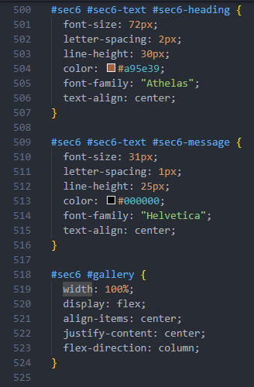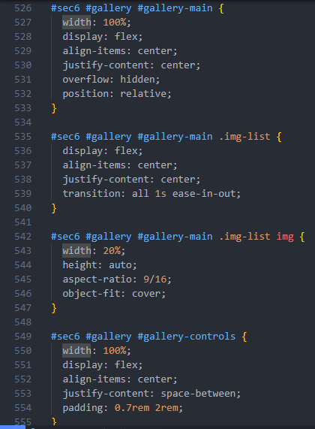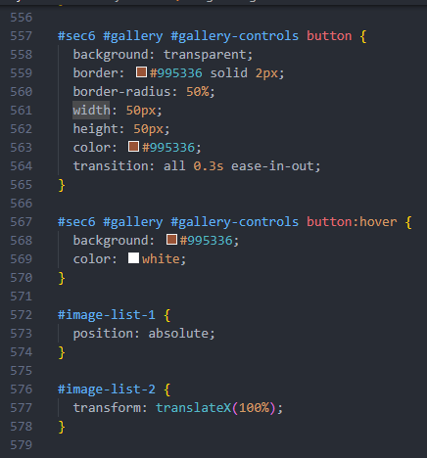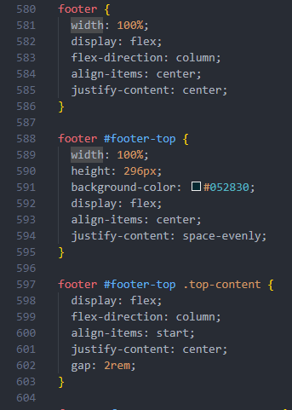

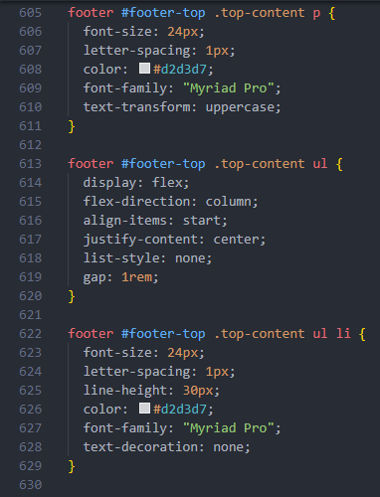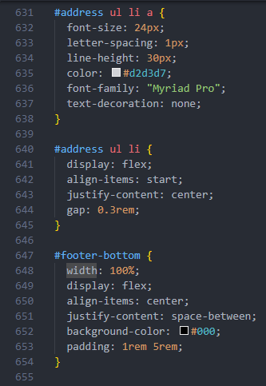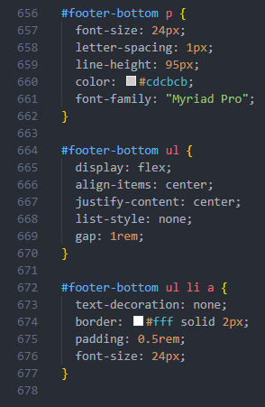

These screenshots showcases our responsive CSS design, ensuring optimal display across all devices. Our CSS adapts seamlessly to varying screen sizes, guaranteeing a consistent user experience.

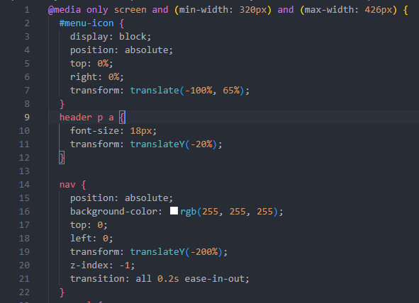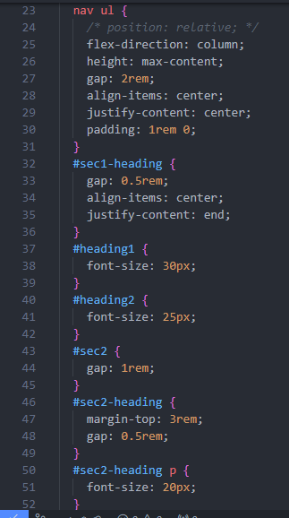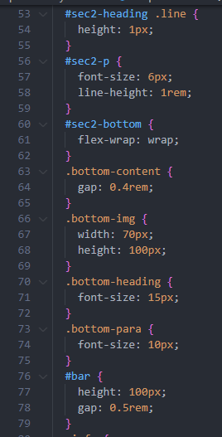

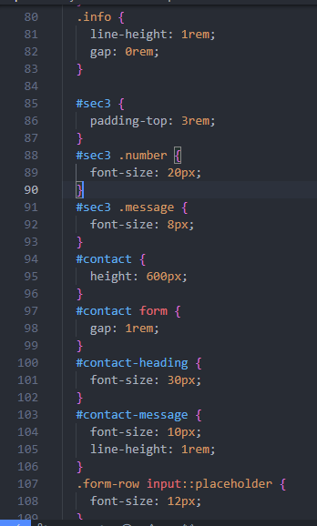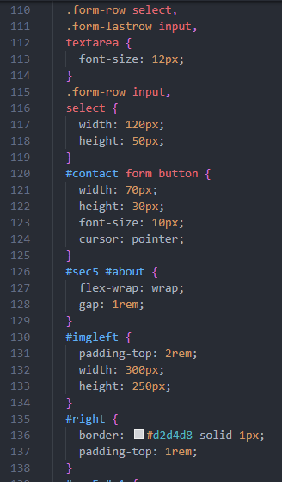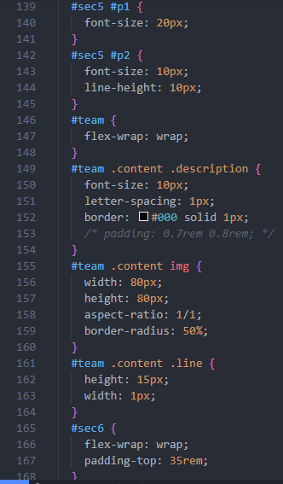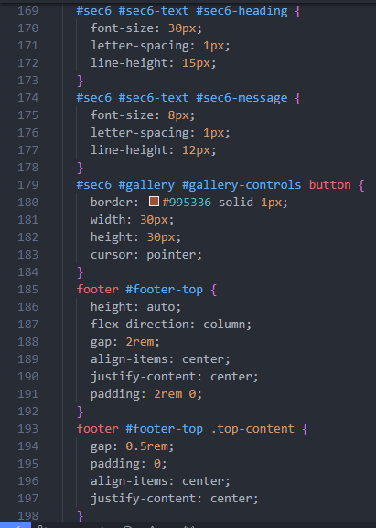

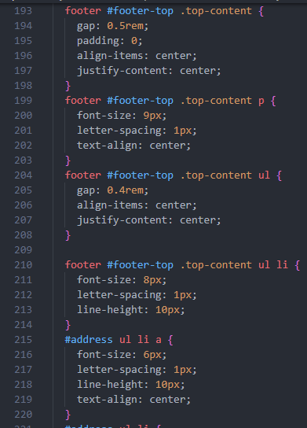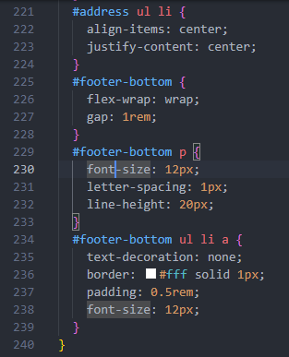

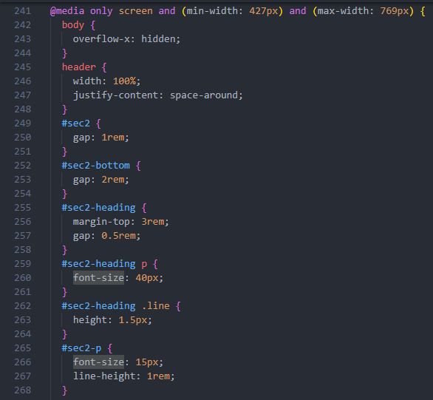

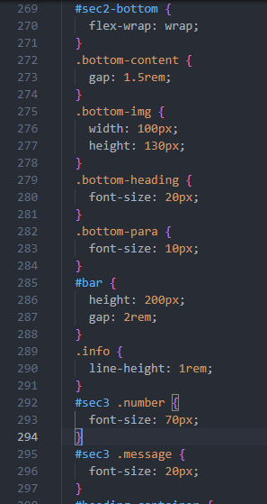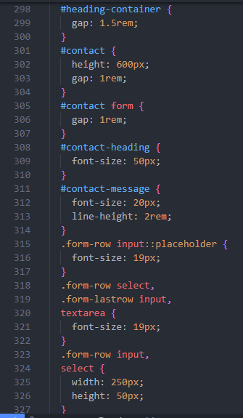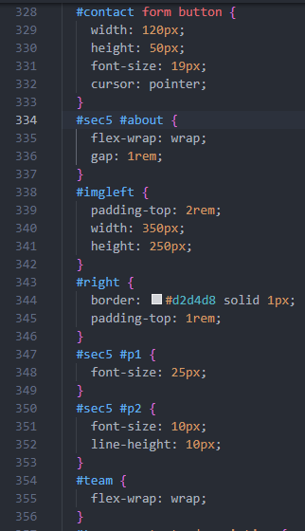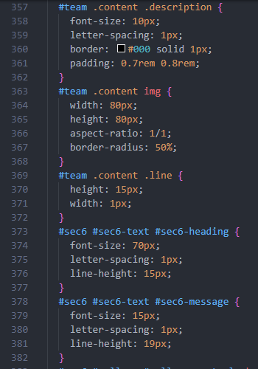

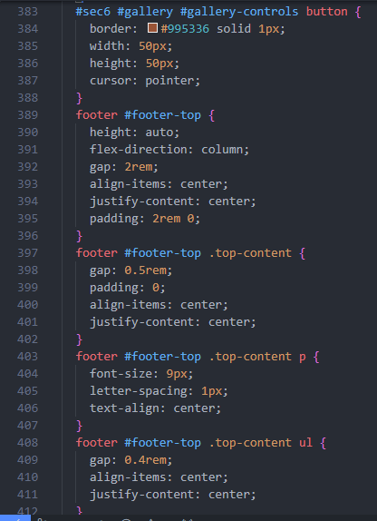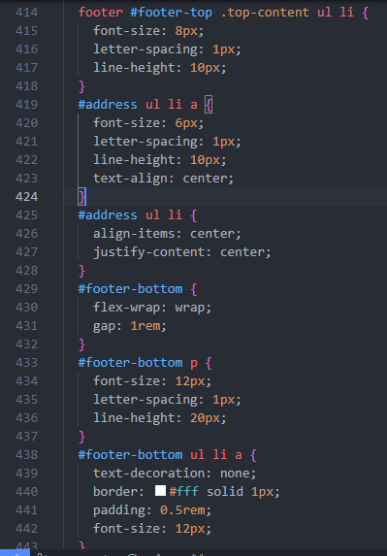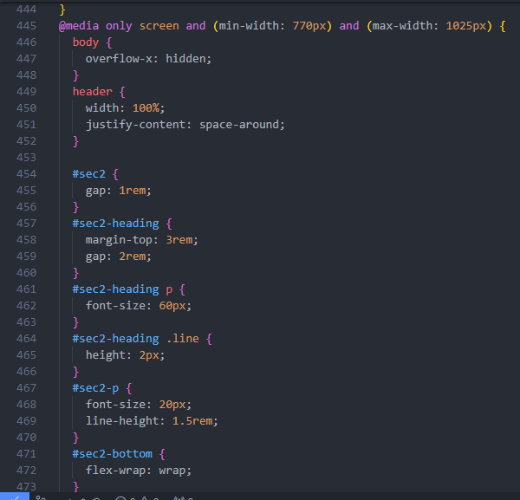

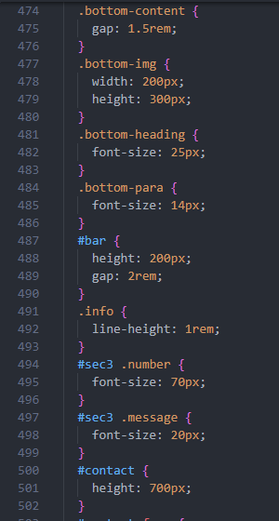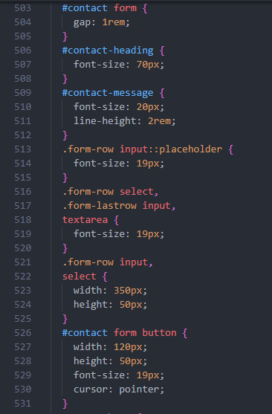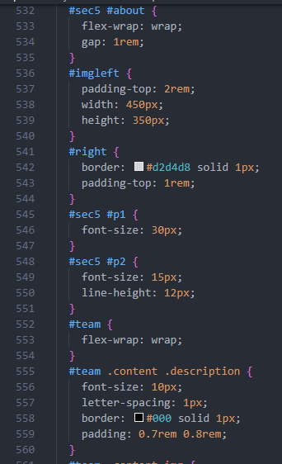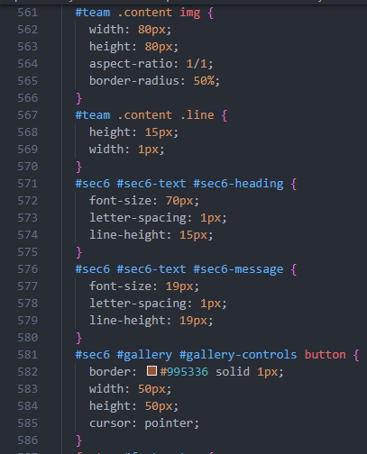

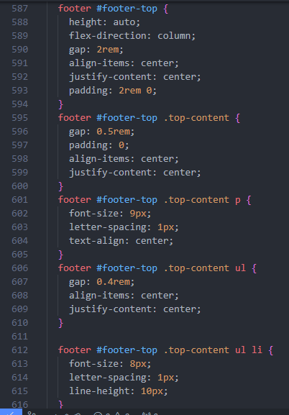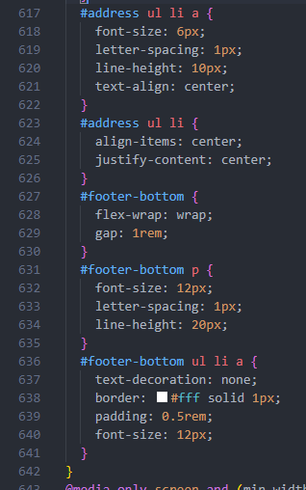

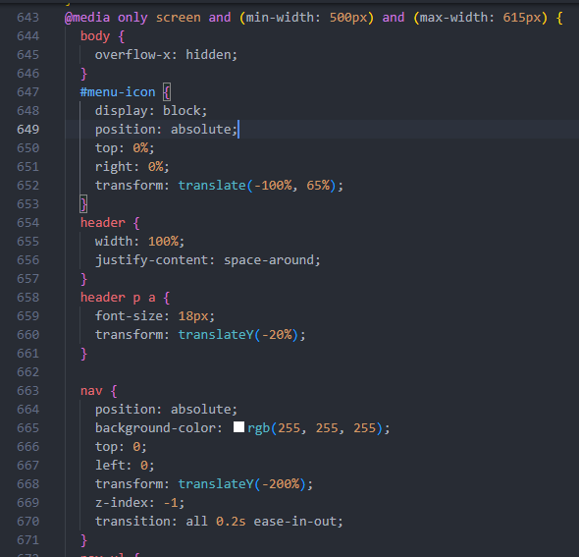

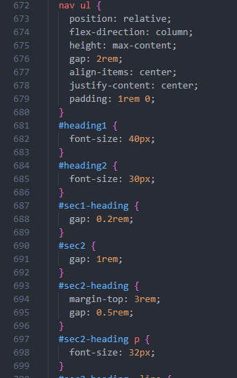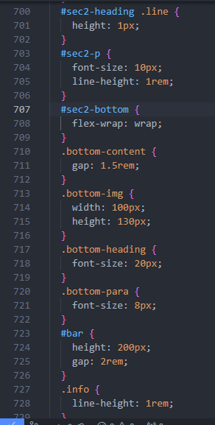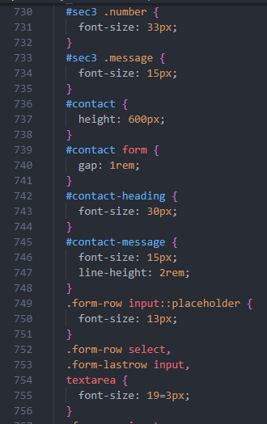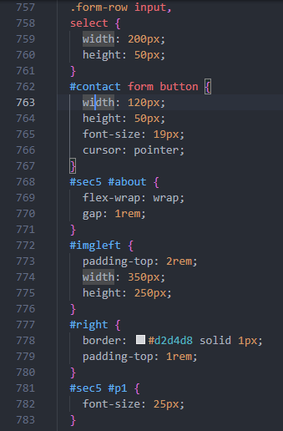

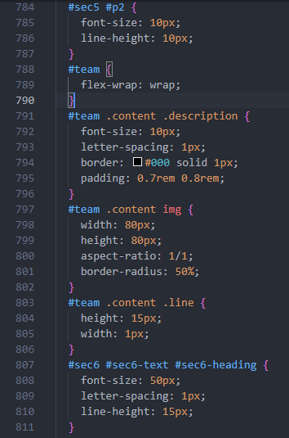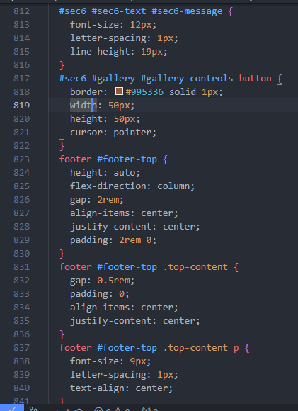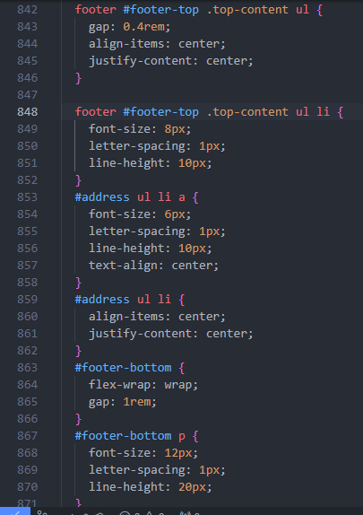

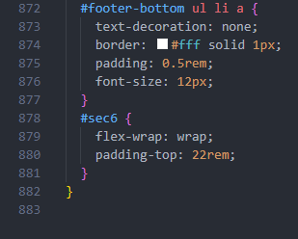

5. Results

This is the result of our commitment to creating a seamless and accessible user experience for travellers across all devices. We understand that modern users expect websites to be responsive and adaptable to their preferred platform, whether it's a laptop, tablet, or smart phone. That's why we made sure that the Dream Travels website is fully responsive, meaning that it adjusts and optimizes its layout and content based on the screen size and resolution of the device being used. This ensures that users can easily navigate the website and access all its features, no matter where they are or what device they're using. To demonstrate the responsiveness of our website, we have included screenshots from both laptop and phone perspectives, showcasing how the layout and design adapt to different screen sizes. From large desktop monitors to small smart phone screens, the Dream Travels website looks and functions flawlessly, providing a consistent and user-friendly experience for travellers on the go. Whether you're planning your next adventure from the comfort of your home or booking a last-minute getaway on your phone, Dream Travels has you covered.

5.1 DEVICE –WIDTH : 320px

PAGE 1-2

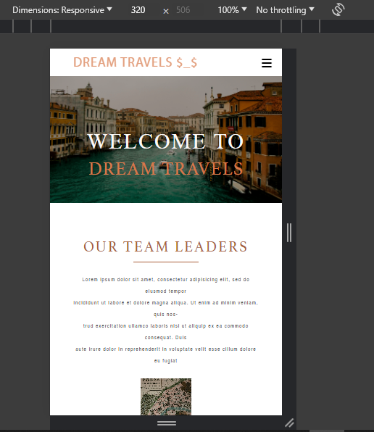

PAGE 1 MENU ICON

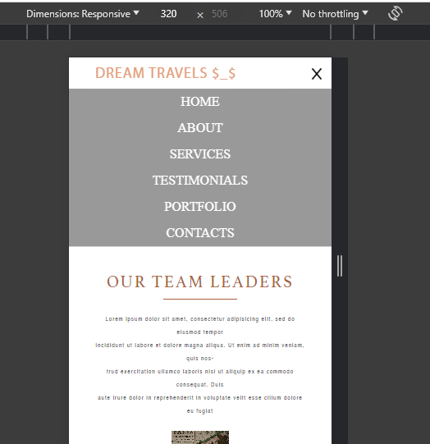

PAGE 2

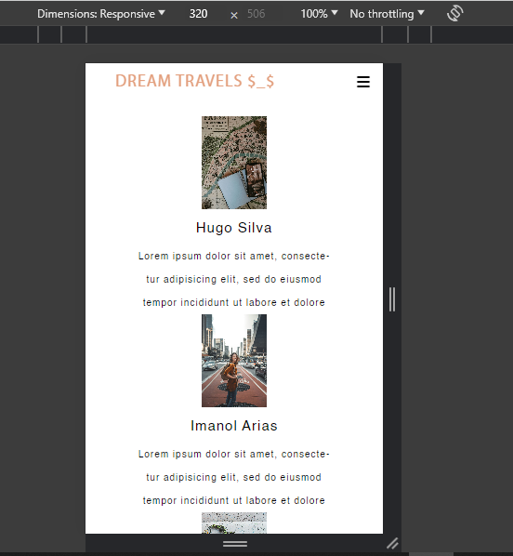

PAGE 2-3

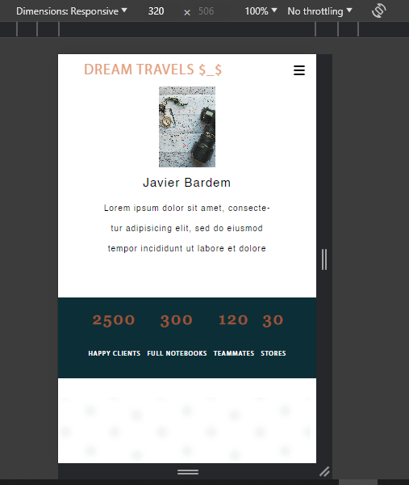

PAGE 3-4

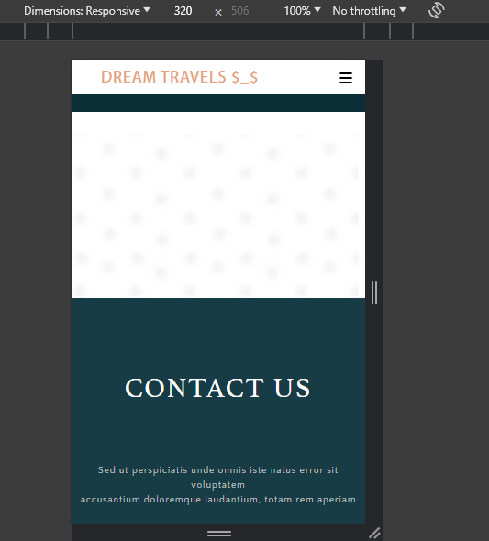

PAGE 4

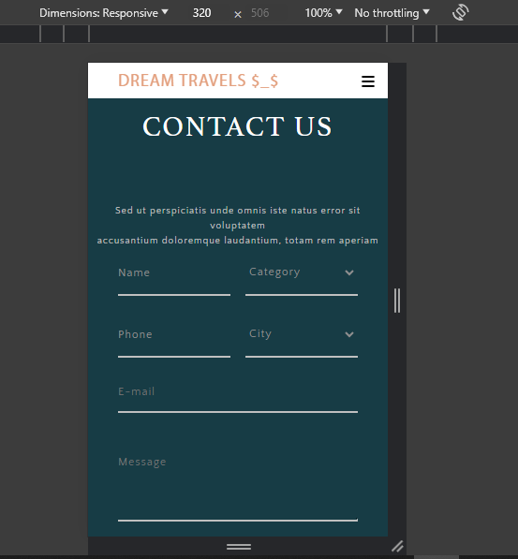

PAGE 4-5

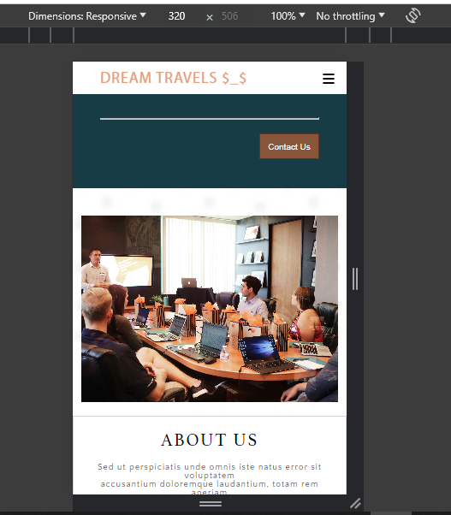

PAGE 5

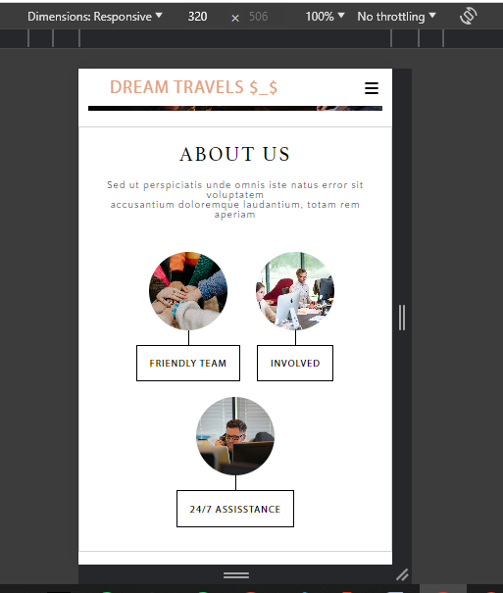

PAGE 6

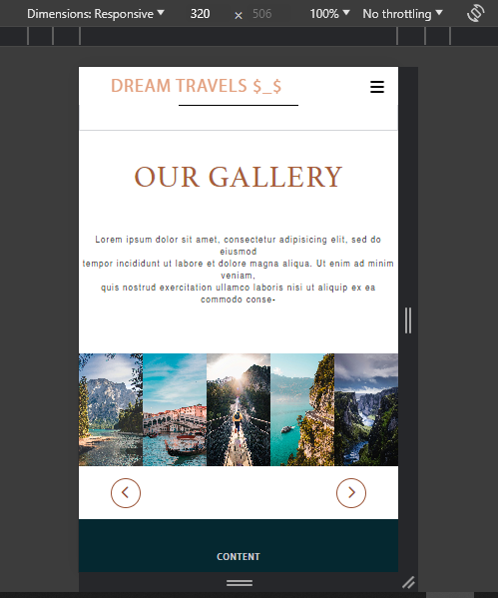

PAGE 6

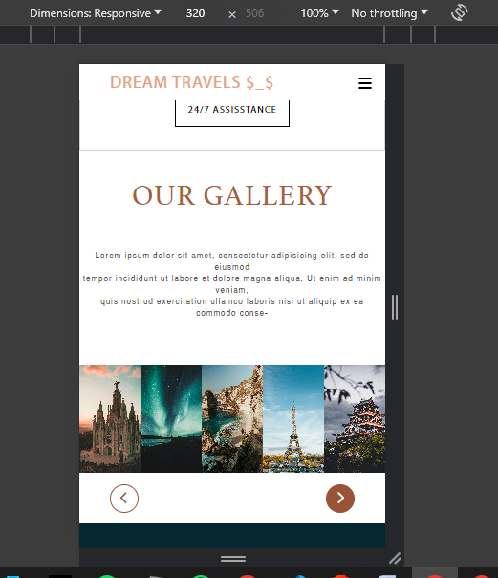

PAGE 7

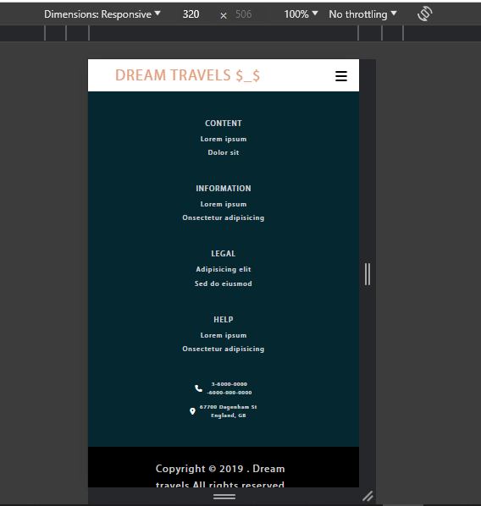

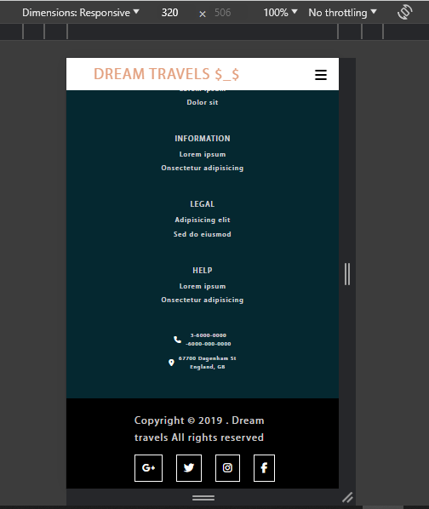

5.1 DEVICE –WIDTH : 375px

PAGE1-2

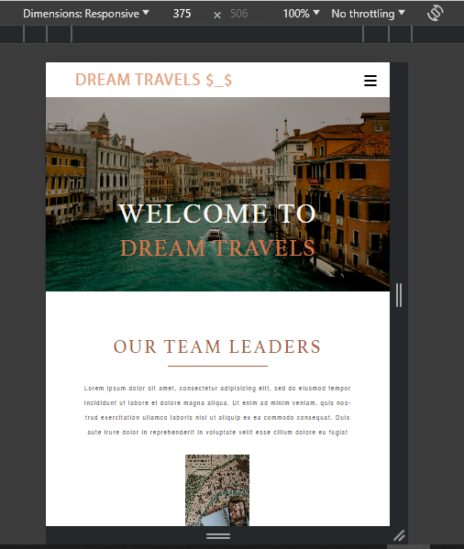

PAGE 1 MENU-ICON

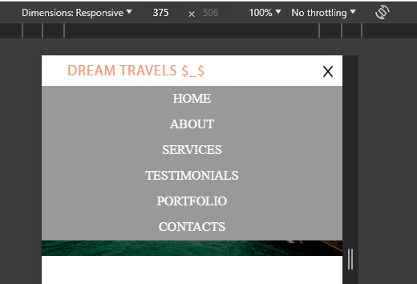

PAGE 2

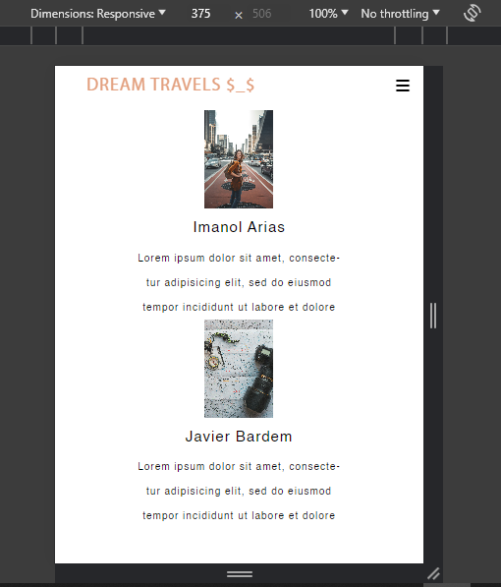

PAGE 3

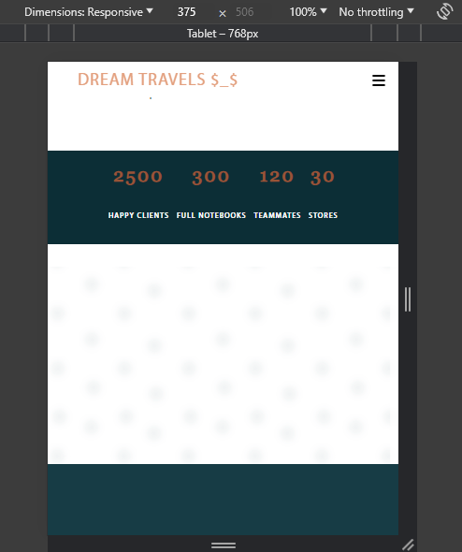

PAGE 4

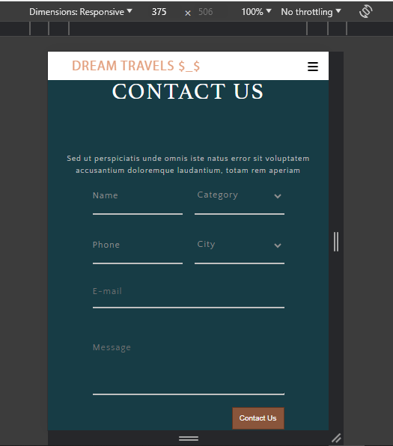

PAGE 5

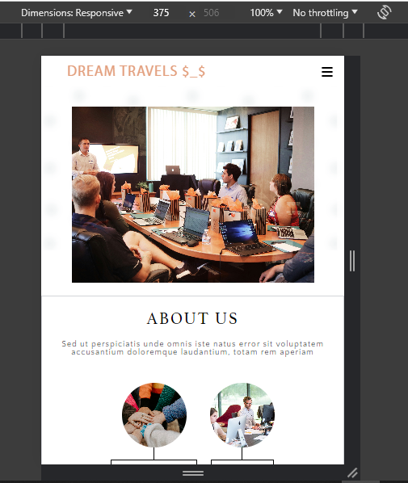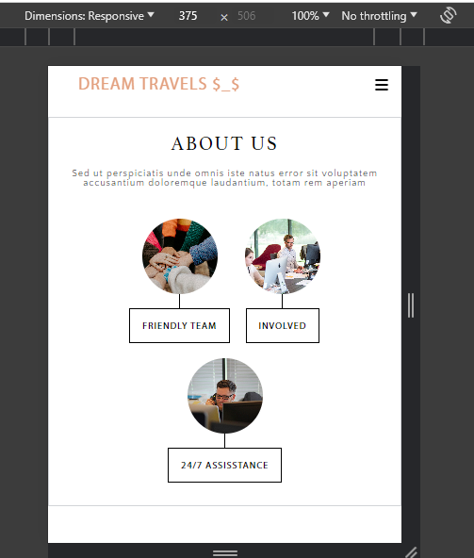

PAGE 6

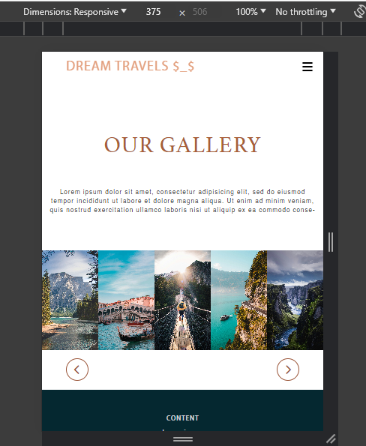

PAGE 7

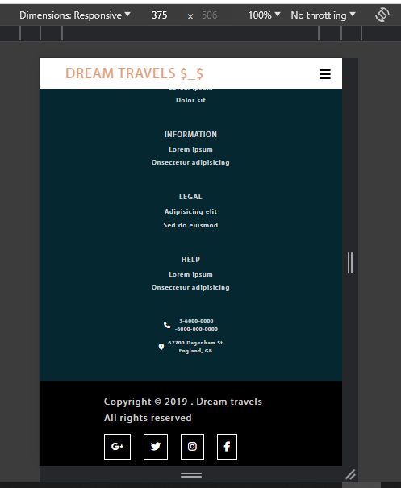

5.2 DEVICE-WIDTH: 425px

PAGE 1-2

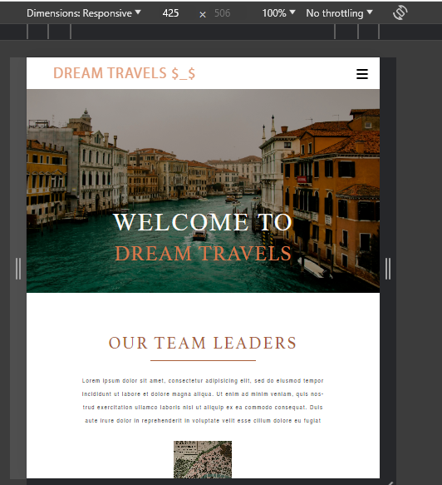

PAGE 1 MENU ICON

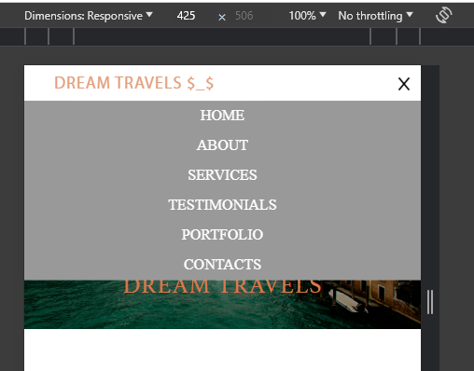

PAGE 2

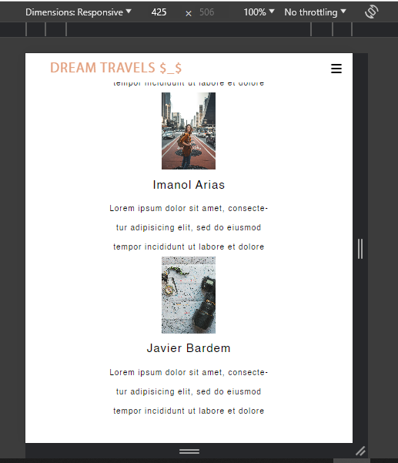

PAGE3

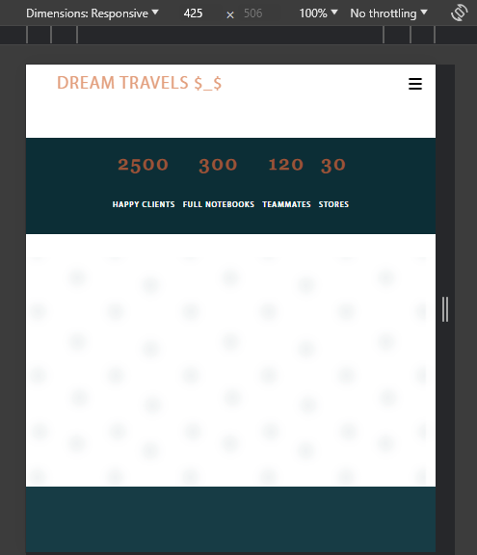

PAGE 4

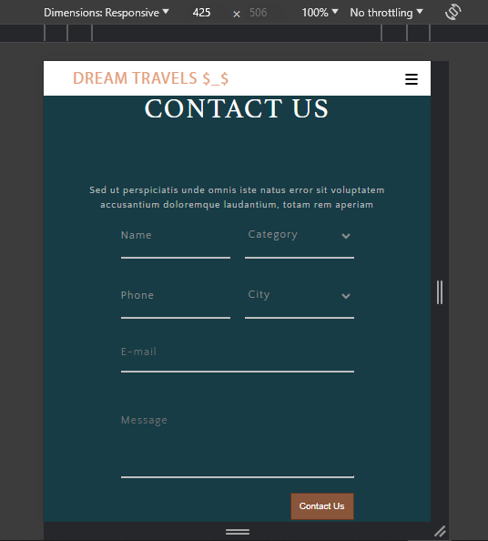

PAGE 5

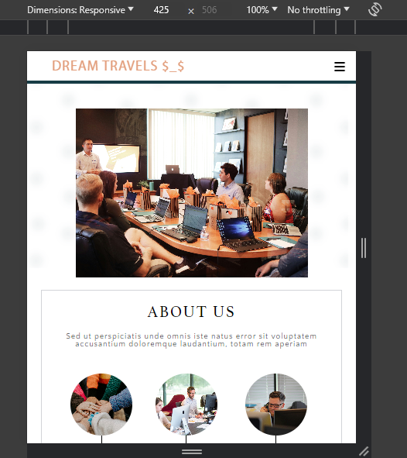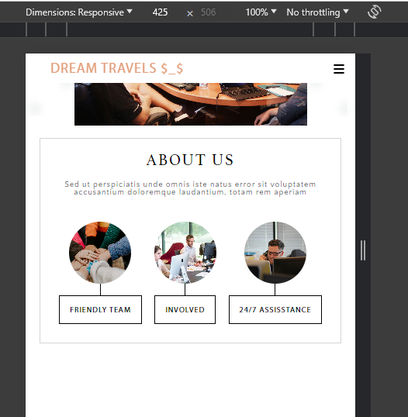

PAGE 6

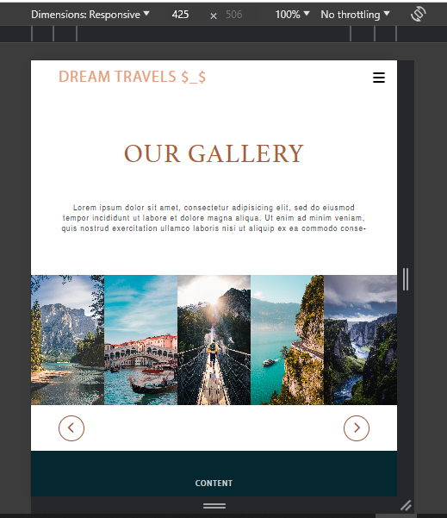

PAGE 7

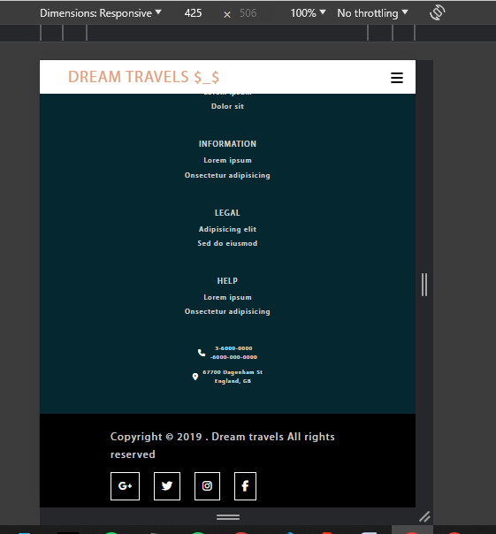

5.2 DEVICE-WIDTH: 768px

PAGE 1

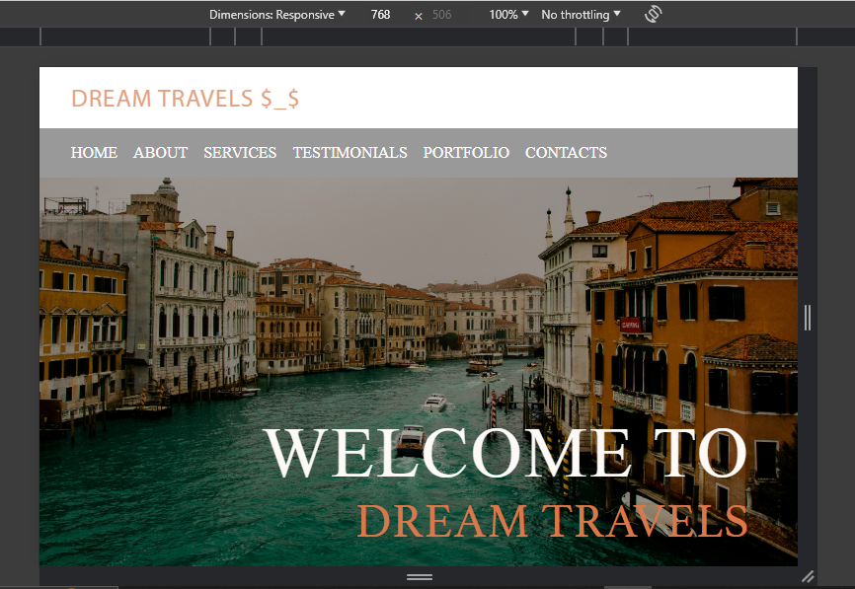

PAGE 2

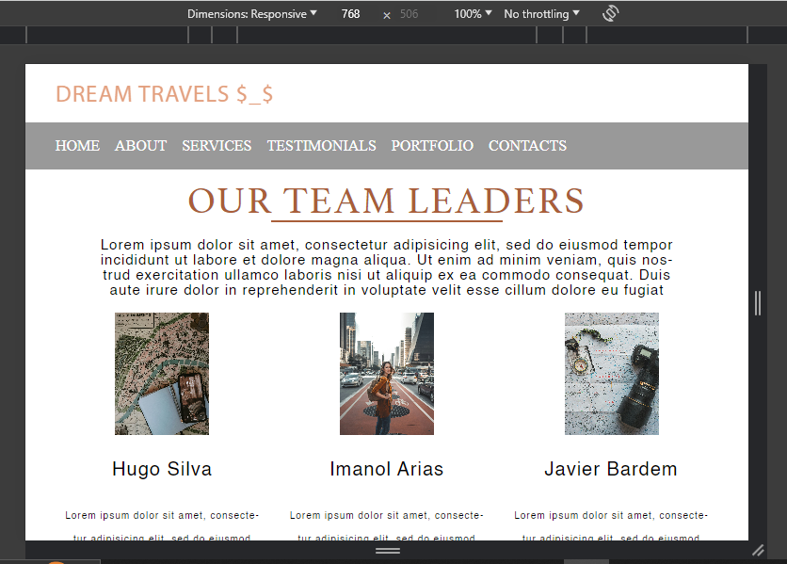

PAGE 3

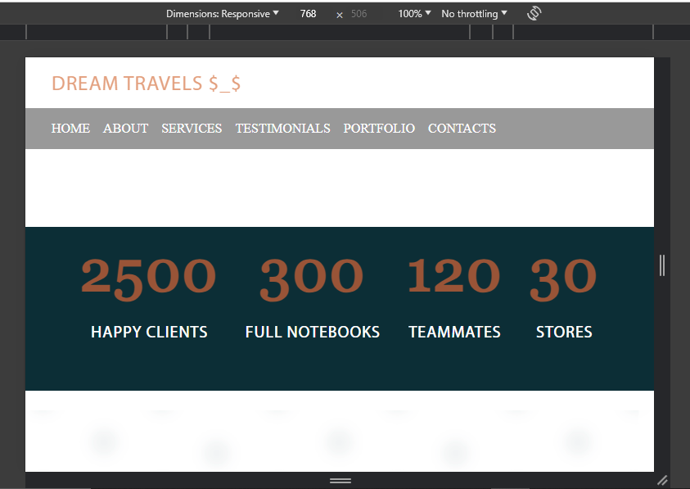

PAGE 4

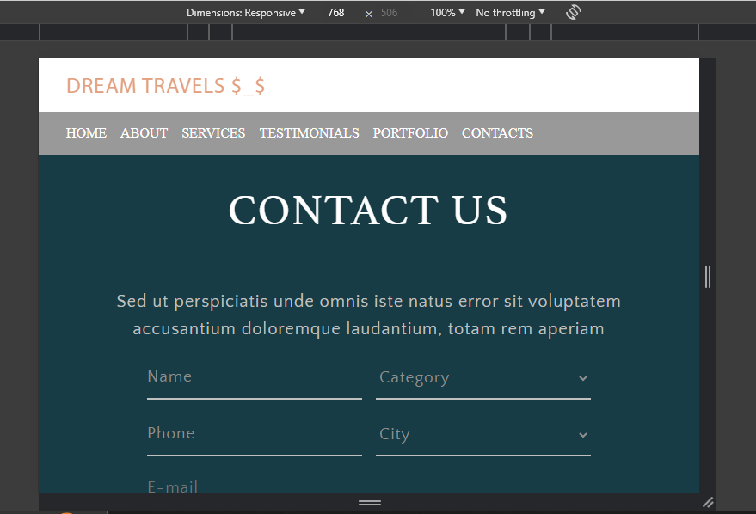

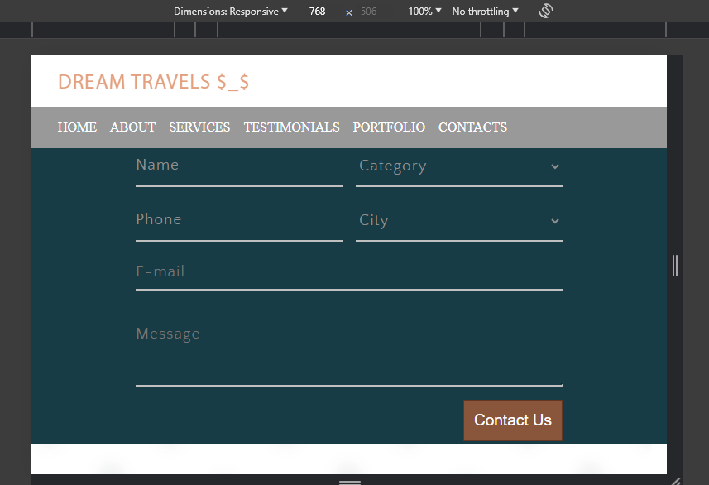

PAGE 5

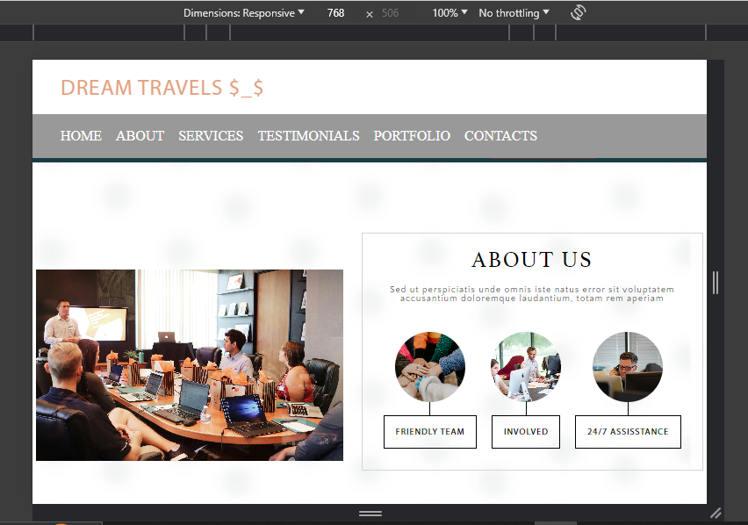

PAGE 7

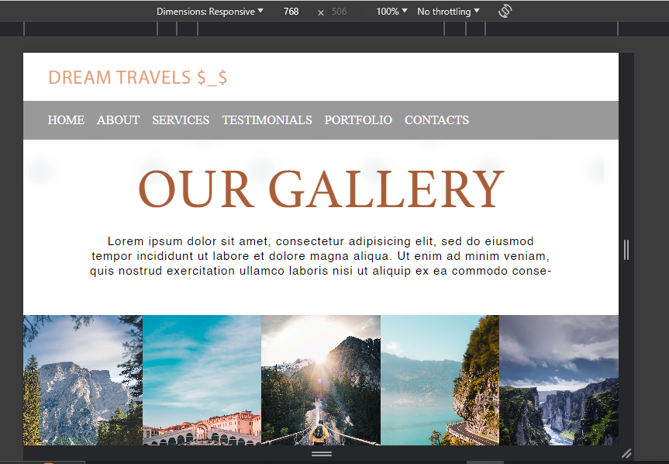

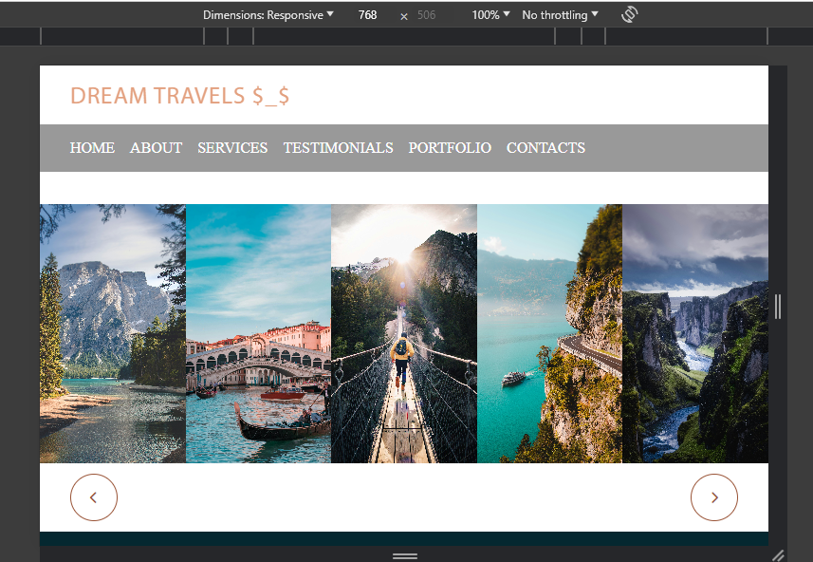

PAGE 8

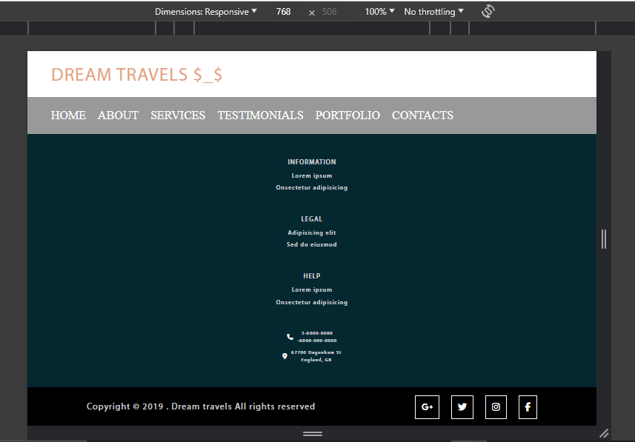

5.3 DEVICE-WIDTH: 1024px

PAGE 1

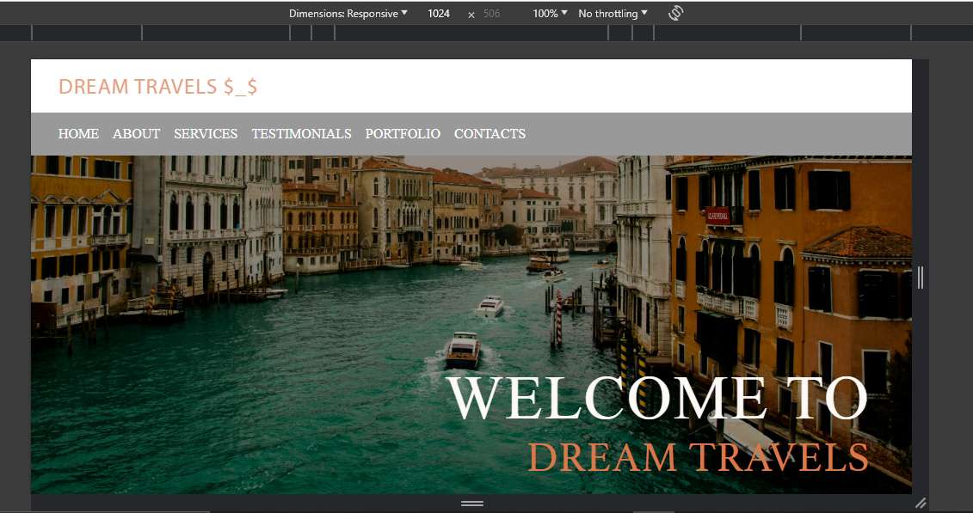

PAGE 2

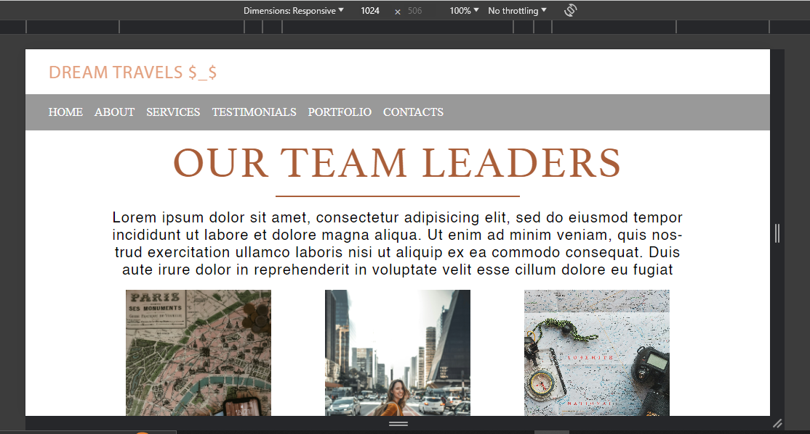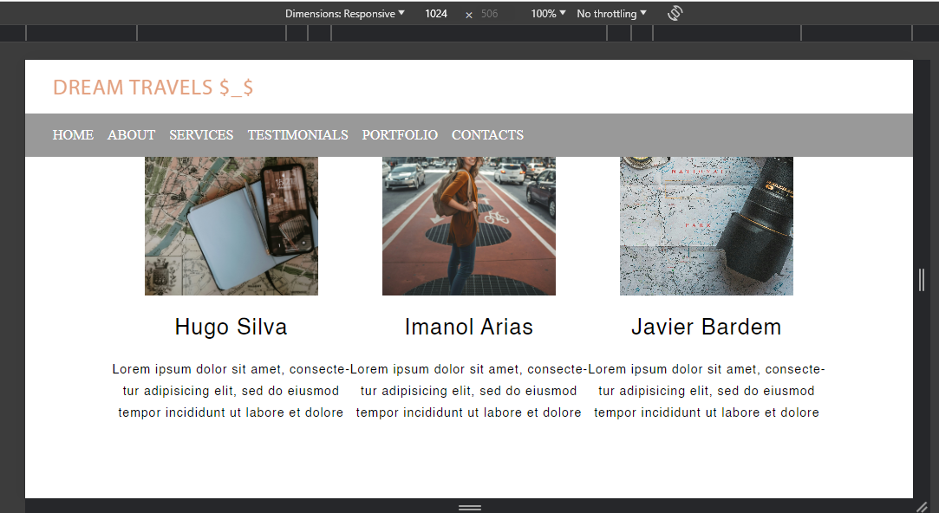

PAGE 3

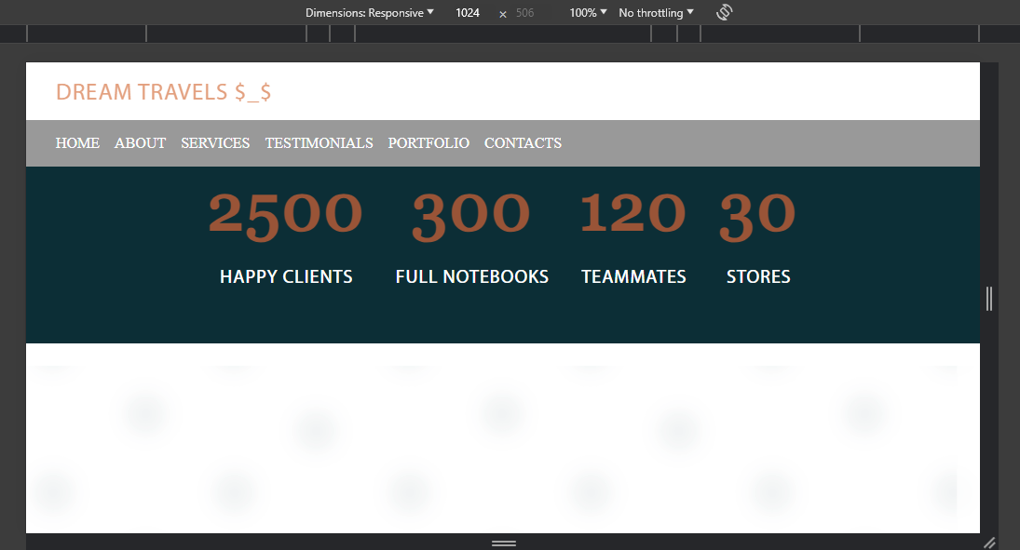

PAGE 4

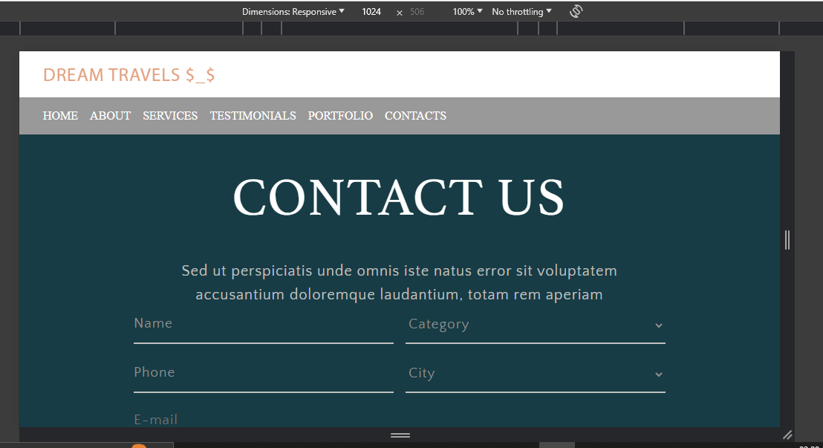

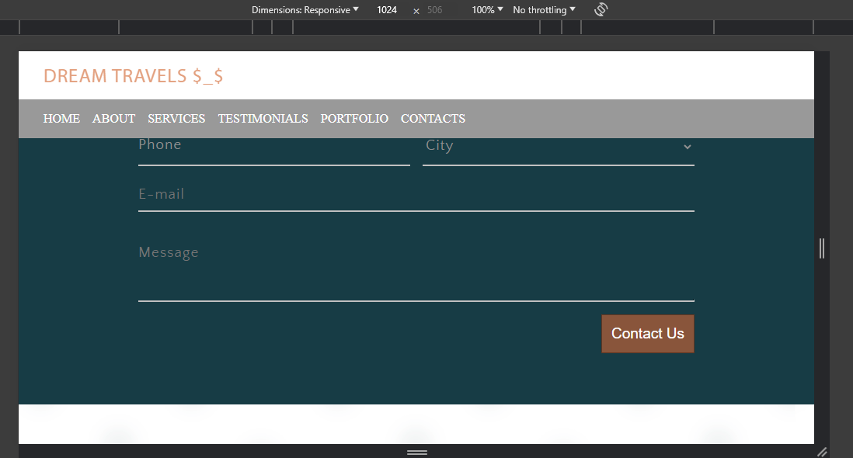

PAGE 5

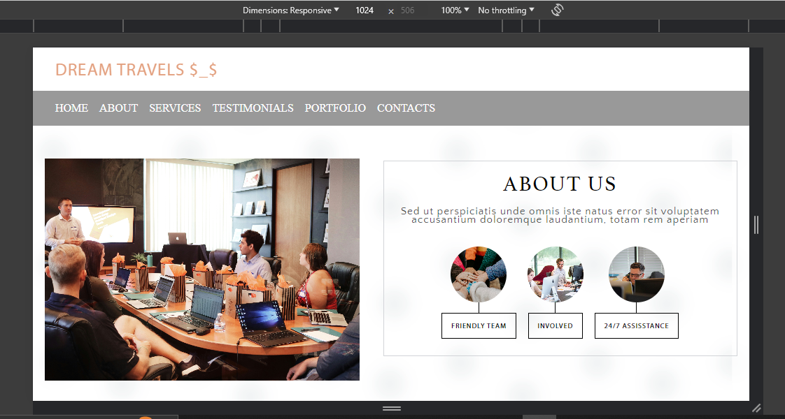

PAGE 6

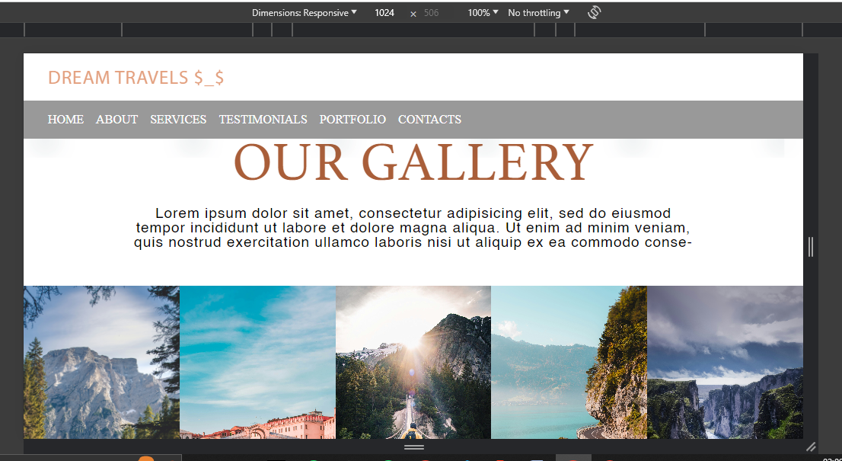

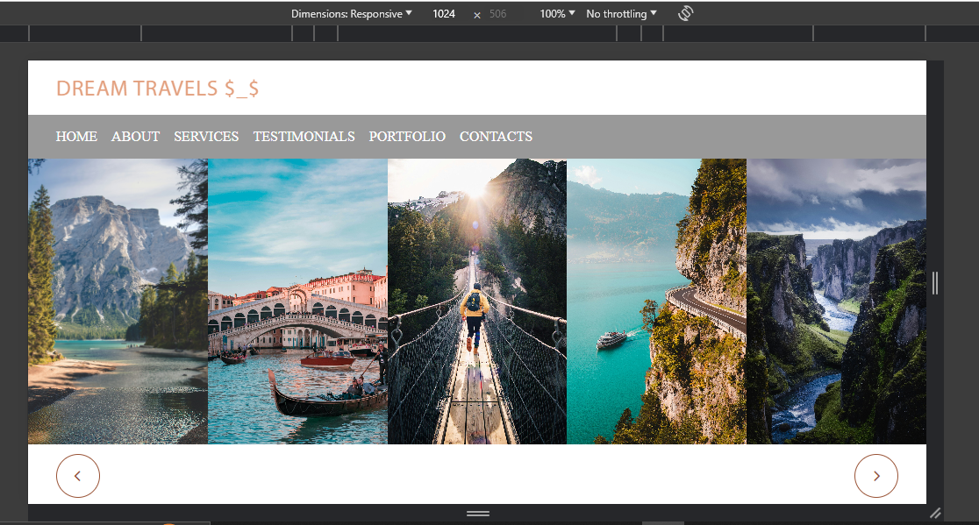

PAGE 7

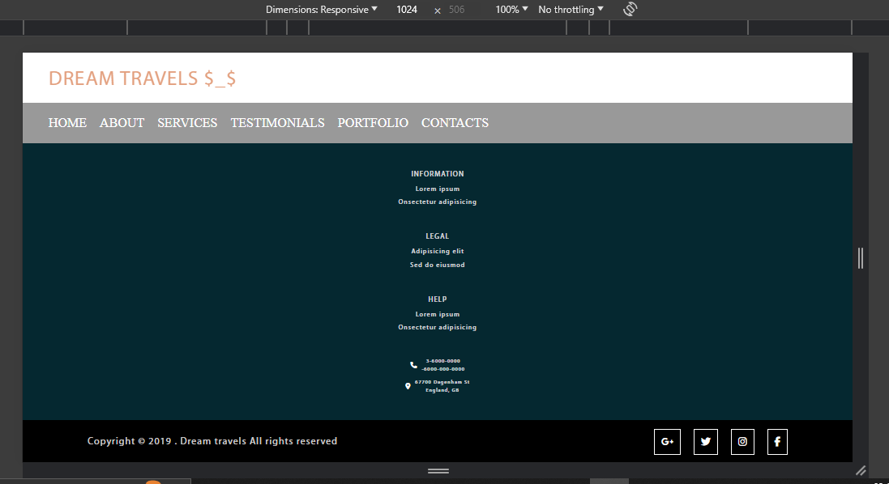

5.3 DEVICE-WIDTH: FULL SCREEN

PAGE 1

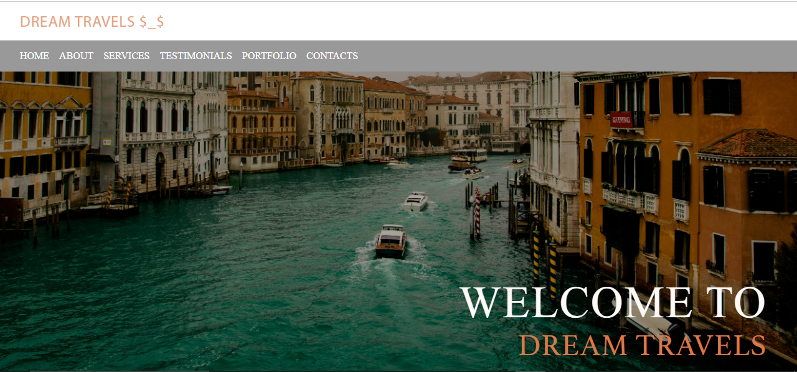

PAGE 2

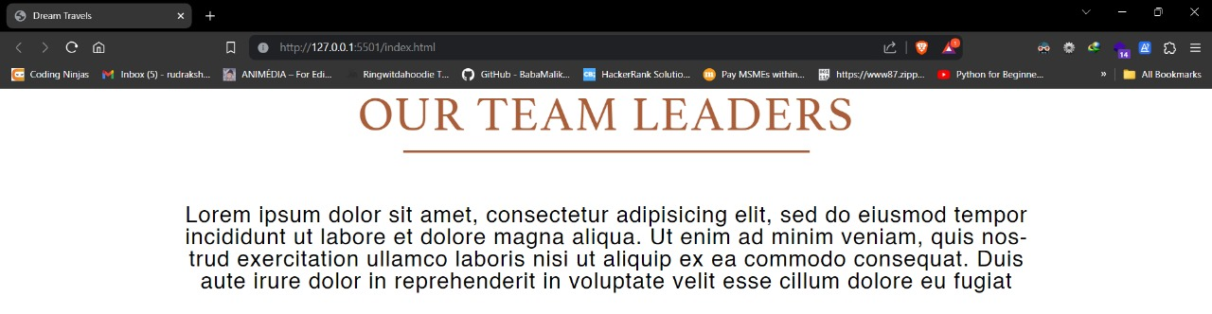

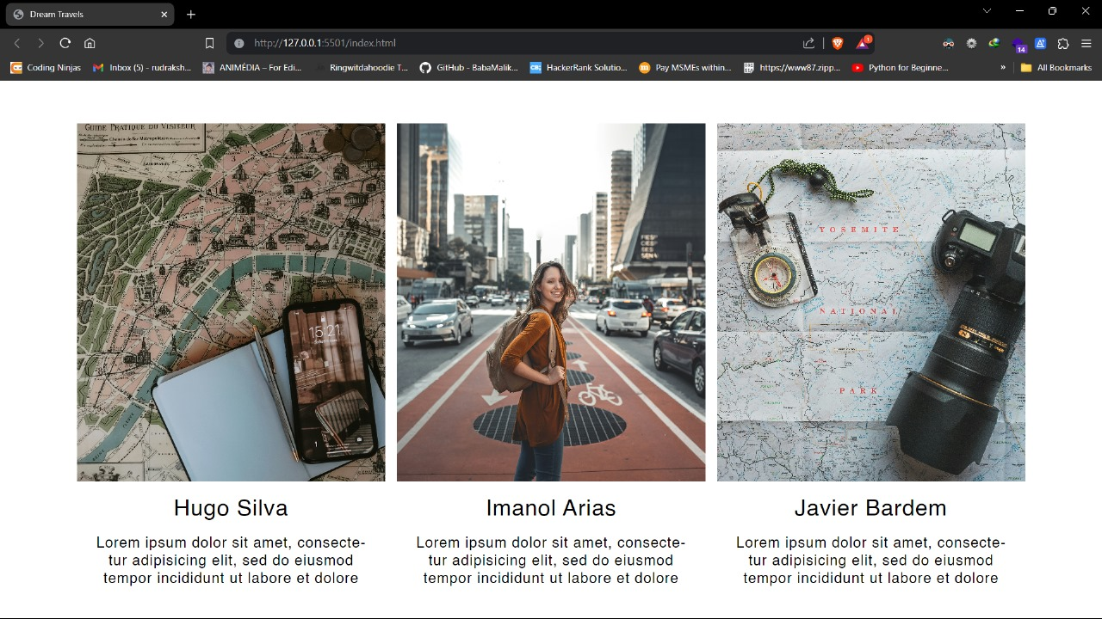

PAGE 3

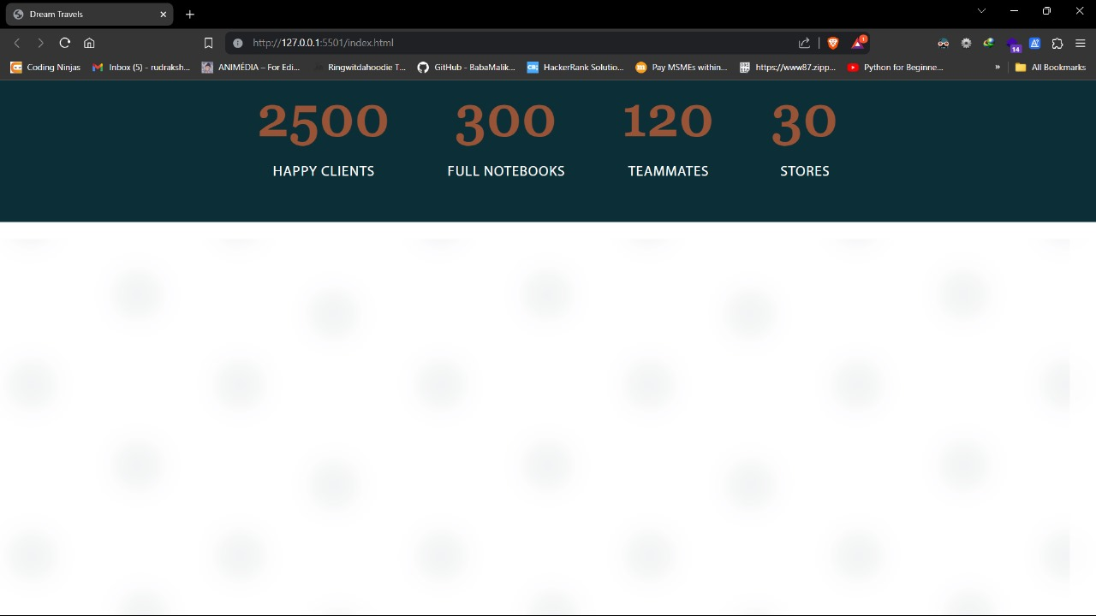

PAGE 4

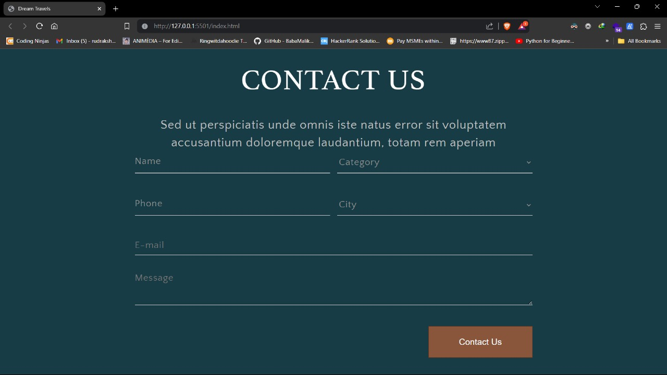

PAGE 5

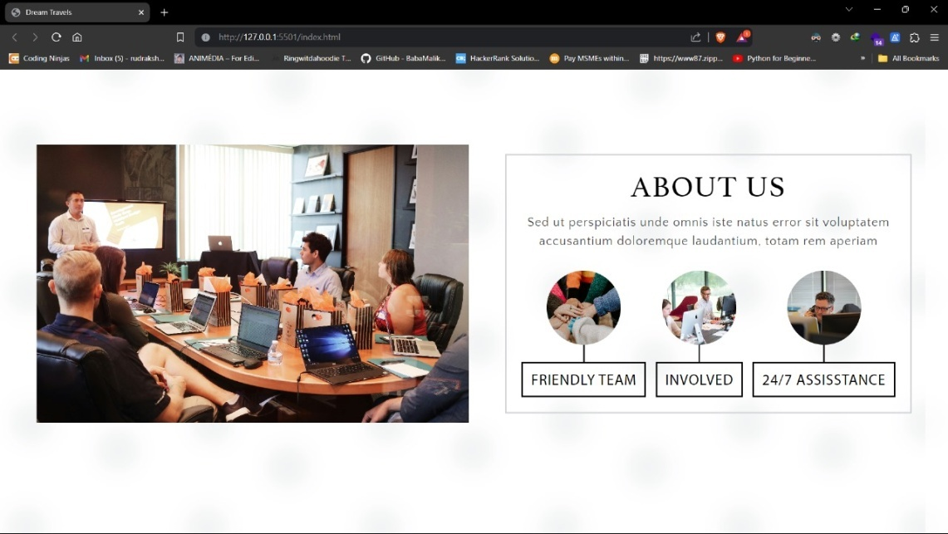

PAGE 6

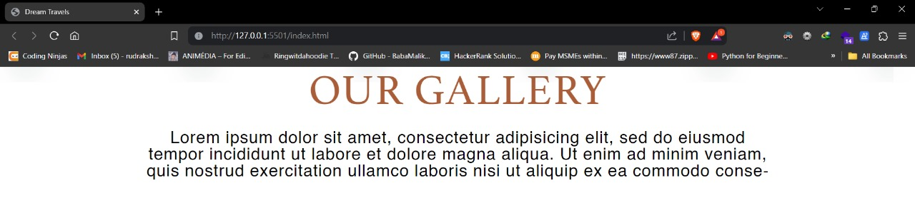

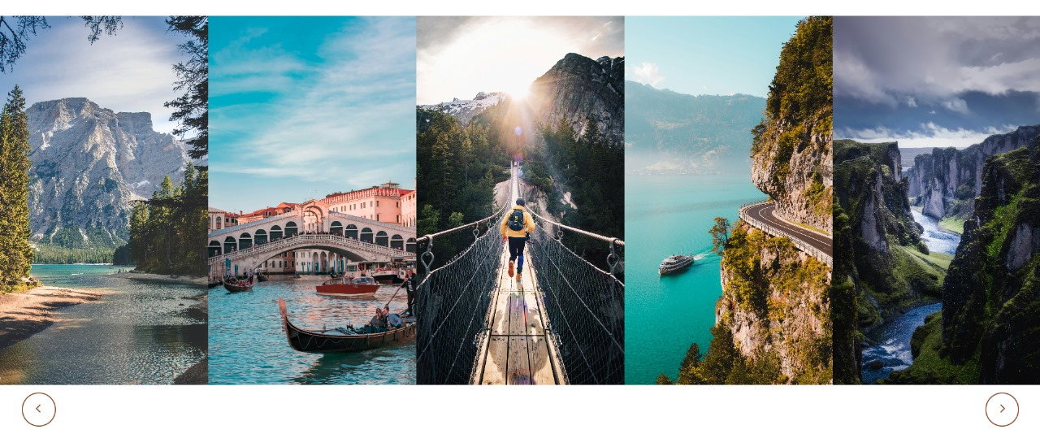

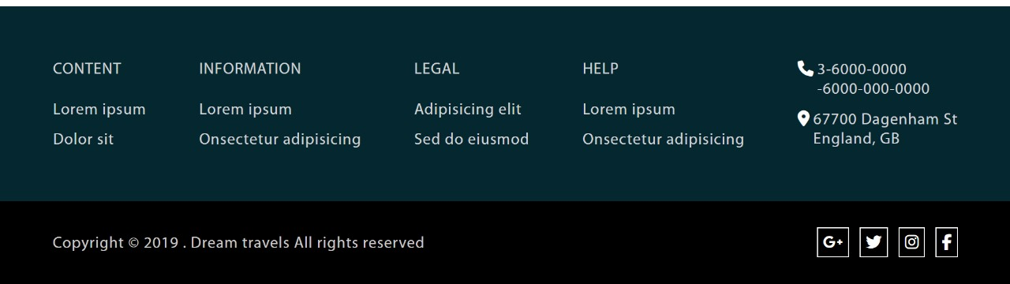

6. References

In developing the Dream Travels website, we drew upon a variety of resources and references to ensure that our project met the highest standards of quality, usability, and accessibility. These references included online tutorials, documentation, coding forums, and best practices guides for web development using HTML, CSS, and responsive design techniques. We leveraged official documentation from the World Wide Web Consortium (W3C) for HTML and CSS to ensure compliance with industry standards and specifications. Additionally, we consulted popular online resources such as MDN Web Docs, CSS-Tricks, and Stack Overflow for insights, tips, and troubleshooting assistance throughout the development process. Furthermore, we utilized responsive design frameworks such as Bootstrap and Foundation to streamline the development process and ensure cross-browser compatibility. By incorporating a diverse range of references and resources into our project, we were able to create a robust and user-friendly website that meets the needs and expectations of modern travellers.